 | Subject: | Madison Park Homeowners’ Association Meeting
 | Date: | February 11, 2013
 | Time: | 7:30 p.m.
 | Location: | Wedgewood Church – Activity Center Annex –
 | Presenters:
 | Meeting Chair: Martin Doss |  | Attendee Count:
31 members
1 CMPD officer
http://www.neighborhoodlink.com/Madison_Park/home/

Welcome: Meeting brought to order by Martin Doss, President at 7:30 pm
President Doss thanked everyone for coming out, and then turned the meeting over to our CMPD Community Service Officer Katie Schwartz.

CMPD Community Service Officer Katie Schwartz provided our monthly Crime Report covering the period from 01/15/2013 to 02/11/2013.
Date | Est Day | Est Hour | Address | Incident Type
23-JAN-2013 | UNK | UNK | 700 ROME CT | Cyber stalking | Victim advised a suspect emailed him several times when he did not want to hear from the suspect
02-FEB-2013 | FRI | 23 | 4600 HALSTEAD DR | Harassing phone calls | Female stated male called her several times when she did not wish to hear from him
07-FEB-2013 | THU | UNK | 5500 WEDGEWOOD DR | Hit and Run | Suspect hit into business’s vehicle and left the scene
NOTE: Addresses where reported crimes occurred are denoted in the “hundred block of” the street.
Officer Schwartz indicated that our neighborhood has been very quiet, however, several other neighborhoods including Sedgefield, Marsh Road and along the I-77 border are experiencing numerous break-ins. They are also experiencing an increase in criminal activity in the Emsley Grove apartments.
Officer Schwartz also stated that CMPD has been providing an increased presence especially along Tyvola and Seneca to enforce traffic laws, pulling people over to issue warnings. What they are finding is that most of the violations are not cut through traffic, but our own neighbors. She also mentioned the motorcycle units, which enforce traffic laws, however, the Westover Division has to request this unit and get on a priority listing by justifying why we are more important than other areas. President Doss indicated to Officer Schwartz that perhaps the decrease in crimes is a result of CMPD spending more time being visible working on traffic issues in the neighborhood. Perhaps the blue lights have run off the criminals. The current focus is both on All Stops and Speeding. President Doss had been passing along concerns of our residents for the last several months (actually years), regarding stop sign running and speeding. Officer Schwartz said this new focus on traffic will continue in the area. This also includes cars parked on our sidewalks.

The question was brought up about traffic (speed signs) along Seneca Place. The person stated they felt there were not enough signs. President Doss had said he would take care of it with CDOT. since it is an issue the neighborhood can handle directly with CDOT. Officer Schwartz indicated she would help facilitate this issue if it was determined that more signs were needed by using our CDOT contact Chip Gallup.

UPDATE: Matt Magnasco, Madison Park Director/Resident, and CDOT Employee after the meeting drove the entire route and recorded all the signs. Finding generally there are signs every 1 to 2 blocks. The only confusing part was westbound (going from Park
> toward South Blvd) at Lamont, where there is a school speed limit 25 on
> one side of the intersection and a regular speed limit 30 just past it.
> Everything else checks out.
>
> Eastbound (South Blvd. to Park Rd):
> Office Depot SL30
> Milford SL30
> Baker SL30
> Duke Energy transmission line: School 25
> Stanfield: School 25 w/ flashers
> Church across from the school: Advisory 25 (not a speed limit, just a
> recommendation)
> W. Wedgewood: SL30
> (nothing the rest of the way to Park Rd)
>
> Westbound (Park Rd. to South Blvd.):
> Park Rd: SL30
> Valley Stream: Advisory 25
> E. Wedgewood: SL30
> East of Lamont: Advisory 25
> Lamont: School 25
> Lamont: SL30
> W. Wedgewood: School 25 w/ flashers
> Stanfield: SL30
> Currituck: SL30
> Glenham: SL30

President Doss had already contacted CDOT upon returning home and then forwarded Matt’s info to CDOT after Matt sent the info to him. Chip Gallup reported first thing today they would take a look and address the situation if needed. President Doss had told CDOT in the past the speed limit changes at Lamont / Wedgewood West Bound were confusing, but until tonight had never heard of any concerns on not enough signs. We have added signs in the past to Tyvola to try and curb the speeding.
7:35 AM
To Madison Park HOA, nggofers@bellsouth.net, Williams, Lamar, Schwartz, Katie A.
From: | Gallup, Chip (rgallup@ci.charlotte.nc.us)
Sent: | Tue 2/12/13 7:35 AM
To: | Madison Park HOA (madisonparkhoa@hotmail.com); nggofers@bellsouth.net (nggofers@bellsouth.net); Williams, Lamar (lawilliams@ci.charlotte.nc.us)
Cc: | Schwartz, Katie A. (kschwartz@cmpd.org)
.
Thanks to all for the help on this. We will review the street as well…
Lamar:
In your travels, please ride Seneca and make any additions or changes in signing that you recommend.
Thanks!
Chip Gallup CDOT

Officer Schwartz also indicated that they have been addressing the late night parking in the Madison Central Park parking lot, and have not seen an issue recently. President Doss mentioned that VP Jo Ann Means worked with Duke Energy to get two of the street lights at the parking lot entrance of Madison Central Park repaired.

Officer Schwartz mentioned that with the coming warm weather we will be seeing more door-to-door sales in the area. She stated in this day and age this method of selling has no place in our society. She recommends that you do not answer the door, and if you feel unsure or frightened to call 911. (It is also a good idea to let someone at your door know you are inside, even if you don’t go to the door).

Guest Speaker - Habitat for Humanity ReStore Neighborhood Blitz‏
Lauren Jones Speaker canceled due to car break down this morning.
The blitz will take place Saturday, March 16th, 2013. Call 7043924495 before March 9th, 2013 to schedule a pick up at your home. See flier for full details.
Montclaire and Selwyn Park neighbors are Welcome to participate. You just need to say Madison Park Neighborhood Blitz when you sign up.

Lauren sent the following message this afternoon:
I wanted to point out that the Neighborhood Blitz is unique because we don't discriminate on the amount of items we will take. So if a neighbor has a small amount of items that we take, we will come pick them up, which is not something we normally do. I also wanted to tell them to make sure they call in at least a week in advance so they can get on the schedule. The objects they donate are sold in the ReStore and profits go directly towards building homes to provide affordable housing in the Charlotte community.
Thanks again and I apologize for the inconvenience.

Lauren
Habitat Charlotte ReStore
VISTA Donations Development
www.charlotterestore.org

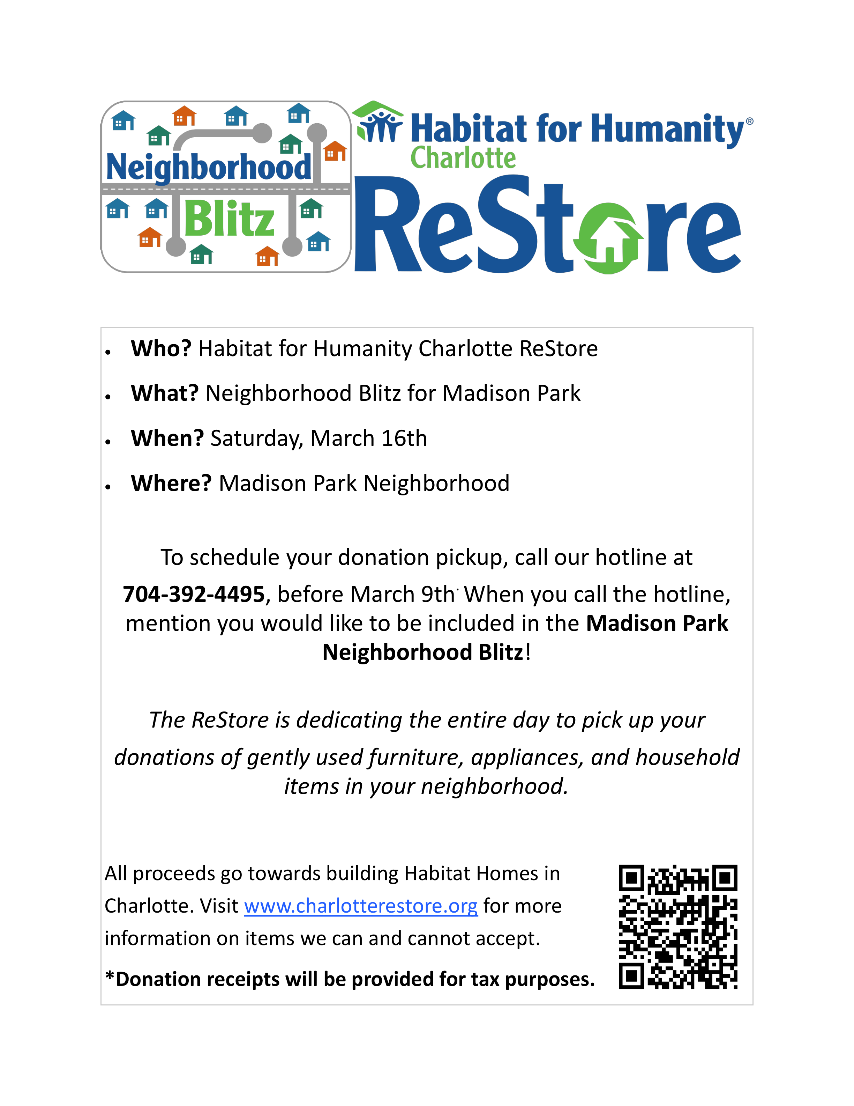

Board Meeting Selwyn Park & Bridlewood Networking 1/15/13
President Doss met with board members of Selwyn Park at their request to assist them with ideas and suggestions on their upcoming neighborhood branding and grant project. The President of Park Ridge, Charles Breitbart was also in attendance. President Doss had assisted him with ideas a couple of years ago on their sign project over the phone, but had never met him face to face.

Bridlewood President Olma Mitchell had called about an hour prior to the meeting with Selwyn Park asking about our auto cling project, and vendor info for our t-shirt vendor and the auto cling.

On 1/31/13 President Doss also met with two members of the Grove Park neighborhood at Old City Hall for 90 minutes to help them with their sign project / identification grant.

Madison Park will continue to network with other communities to help them with their projects, and gain fresh ideas and perspectives. Since 210 when we completed our neighborhood signs, President Doss has spoken to about 25 different neighborhoods on our project.

Common Nuisance Violations and Fines Call 311 to Report
This is being shared once again as an educational tool, and to help keep our streets in Madison Park looking their best. Code enforcement is working with us to curb this activity in our community, and will issue fines on repeat violators if the nuisances are not stopped. Please help your neighbor with yard waste, and reminding them to get their cans off the curb. If you know someone is out of town, and they rolled their cans out and left, consider taking them off the street for them. A quick spot check last Thursday morning found over 90 locations that failed to remove their cans by midnight the day of pick up as required by the code. Also 7 locations had cars on the lawn. We also had 3 mattresses, sofa, broken furniture, and a refrigerator out after pick up the last two weeks. These things have been discussed over and over, in some cases for a decade by our HOA, and need to be corrected for the good of the community. These are not Madison Park Rules, not the rules of President Doss, or our code inspector’s rules, but rules of the City of Charlotte. Please do your part to try and make sure you follow the rules! We actually have some locations that have 6 or 7 days a week something piled on the curb or street, at most 2 days should be it. If you want to bag your leaves early leave them out to the side of your home or rear, and move them to the street the correct day. Garbage bags do nothing but trash our neighborhood piled out days before pickup. The streets should only have items lining them the day prior to pick up, and the day of pick up. Thanks for doing your part to help keep Madison Park looking its best. Most of you do the right thing. Some of you unfortunately 5% or less just do as you please, and even worse do this repeatedly after getting educational materials from codes. Fines will be issued by code enforcement if needed. To report issues call 311. President Doss also mentioned the effort of the City to keep the sidewalks clear of trash cans, yard waste, and cars. He mentioned how last week he noticed the sidewalks on Tyvola were blocked in several spots on trash day. When he circled the block again a short time later a city worker had came through and moved every can on the sidewalk to the grass behind the sidewalk. It is ridiculous the city has to keep telling people to keep their cans off the sidewalks, and even worse they have to pay someone to come out and move the cans off the walks. The city started this effort over a year ago on Tyvola, before the Myers Park high school student was killed when his bike handlebar hit a trash can on the way to school and he fell into a city street, and was hit by a truck. The arms on the sanitation trucks can reach the back side of the sidewalk to pick up the cans where we have no planting strips such as Tyvola.

Common Nuisances / Fines
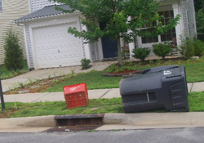 | Rollout Containers
$50 FINE
Rollout containers should be placed at the curb no earlier than the day before the collection day and must be removed by midnight on the collection day. Rollout containers should not block the sidewalk.
$25 FINE
Rollout containers may not be stored in front of a home. \

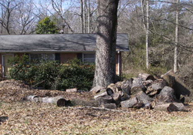 | Yard Waste
$50 FINE
Yard waste should be placed at the curb prior to the day preceding collection day and in small, neat piles.
Leaves must be placed in cans or untied bags.
Limbs must be no longer than 5 feet and no larger than 4 inches in diameter.
Tree trunks must be 4 inches in diameter or less. The city will not collect tree stumps.

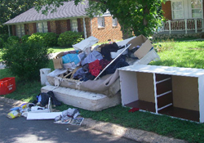 | Bulky & Junk Items
$50 FINE
Eligible items must be scheduled for collection. Call 311 to schedule a pickup.
Items cannot be placed at curbside prior to scheduling.
Bulky items can only be placed at the curbside prior to the day preceding the collection date.

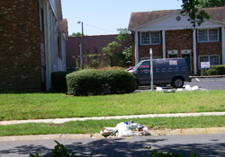 | Neglect of Property
$50 FINE
Neglect of property is causing or allowing unsightly litter, tall weeks and grass, yard waste, foul odor, dead animals, junk, unsecured appliances or potentially dangerous devices to remain on or emanate from the property.
You may also receive a violation if you discard, abandon or cause these issues on public property, private property, vacant lots or any pond, stream, or body of water or banks therof with the city limits.
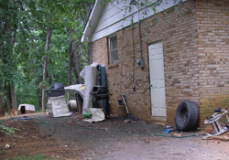 | Dilapidated Condition
$50 FINE
Property that is in a littered condition, such as dilapidated furniture, appliances, machinery, equipment, building materials, automotive parts, tires, or any other items which are in a wholly or partially rusted, wrecked, junked, dismantled or inoperative condition which are not completely enclosed within a building or dwelling will result in a violation.
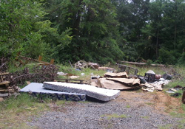 | Illegal Dumping
$500 FINE
Disposing of or discarding any litter on private or public property without the owner's permission will result in a violation.

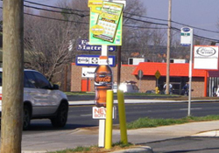 | Signs
$100/500/1000 FINE
*based on number of offenses
Signs may not be placed within 11 feet of the edge of the pavement of any road, roadway, street, or alley or within any public right-of-way, or upon any post, pole, tree, tree stake or guard, shrub, fire hydrant, or upon anything else within 11 feet of the edge of the public right-of-way or upon any bridge or overpass within the city limits.
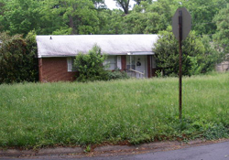 | Tall Weeds & Grass
$50 FINE
Failure to cut weeds or grass and overgrowth exceeding one foot on the average will result in a violation.
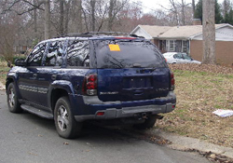 | Abandoned Vehicles
Vehicle Towed
Vehicles will be in violation if they are
- On any public street or highway longer than seven days
- On property owned or operated by the city for longer than 24 hours
- On private property without the consent of the owner, occupant or lessee thereof for longer than two hours
 | Hazardous Vehicles
Vehicle Towed
Any motor vehicle which appears to be hazardous in nature will result in a violation.

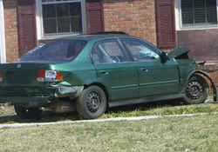 | Junk Vehicles
Vehicle Towed
It is unlawful to have more than one junked motor vehicle on the premises of public or private property.
One junked motor vehicle in its entirety can be located in the rear yard, if the junked motor vehicle is entirely concealed by an acceptable canvas covering.
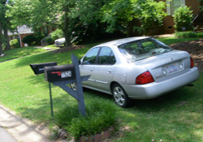 | Parking on the Front Lawn
$25 FINE
Parking in the front yard or front and side yards of a corner lot is a code violation, except if the vehicle is on an improved driveway or parking pad.

How To Prepare Garbage For Collection:
- Place the garbage cart at the curb by 6:30 am on your scheduled collection day.
- Bag all garbage before placing it in the garbage rollout cart. Do not overfill carts or place garbage items outside of the cart. Items outside the rollout cart will not be collected.
- Please place the cart within 2 feet of the curb and with the handle facing toward your property. Do not block the sidewalk.
- Please allow 3 feet of space between collection items and other obstacles such as mailboxes, phone poles and vehicles.
- Place the cart at the curb no sooner than the day before collection. The cart must be removed from the curb by midnight on the day of collection. A minimum $50 citation may be issued if you place the cart at the curb sooner than the day before collection or leave it at the curb past midnight on your collection day.

If you need a copy of the recycling calendar use this link. Cut and paste the following link into your browser:

http://charmeck.org/city/charlotte/SWS/CurbIt/Recycling/Documents/FY13%20Recycle%20It!%20Calendar.pdf

If you have physical reasons you can’t get your can off the curb, or out the correct day you may qualify for Disability Collection Services.
Disability Collection Services
Residents physically unable to take their garbage and recyclables to the curb for collection may quality for Disability Collection Services (backyard collection). To see if you qualify for disability collection services, please read the instructions below.
Disability Collection Service Instructions
- Complete the Disability Collection Verification Form
- Resident must have a physician complete the “Physicians Statement” portion of the Verification Form
- A form must be completed for each resident in the household, whom is requesting service
- Resident must sign and date form
- Once entire form is completed, fax to 704-353-0330 or mail to: City of Charlotte Solid Waste Services Department, Administration, 1105 Otts Street, Charlotte, NC 28205
- Once the form is received by Solid Waste Services, a request number will be issued
- Within 2 business days, the resident will be contacted by a Solid Waste Services Contract Technician to schedule an onsite interview with the resident
- After the onsite interview has been conducted, backyard collection services will begin within 2 weeks. The resident will receive a phone call stating when service(s) will begin.

Madison Central Park Ant Hills
CMS Todd Sherrill was made aware of Ant Hills back in November 2012 by President Doss. He said he would have his grounds crew address. On 1/28/13 President Doss was made aware of a facebook post where a couple noticed several mounds near the playground. They stated they were bitten while at the park, and they wanted to know if anyone knew how to get rid of them.

This property is not our property, and is owned by CMS. President Doss sent a message to Mr. Sherrill. He immediately responded the following:

Date: | 1/28/2013 1:44:20 P.M. Eastern Standard Time
From: | todd.sherrill@cms.k12.nc.us
To: | Martydoss@aol.com

This is for CMS to handle. There are a lot of EPA laws we have to follow. I will have this taken care of ASAP.
Thanks,
Todd
(704) 506-5738

Madison Park HOA does not have an official Facebook Page. We encourage if you have issues to use our web site discussion page, or e-mail us at Madisonparkhoa@hotmail.com.
We have several thousand people visit our web site each month, with hundreds visiting on any given day. This is the best place for us to get the info out to a large number of people, and it is the only official place that we monitor. Join our distribution list by making a request to join to Madisonparkhoa@hotmail.com
In this case a resident forward the info to President Doss after reading the post knowing that no one should be doing anything on the property without CMS permission. Her assumption was exactly correct, as one can see from the quick reply of CMS. In the future simply contact us with things you see, and we will make sure the proper officials know so they can address your concern.
Community Police Relations Award Nominations until 4/1/13
http://charmeck.org/city/charlotte/CRC/Forms/Pages/PCRNominationForm.aspx
Have you had a good experience with any of our Officers? Community Police Awards are now excepting nominations. You can click the link here and nominate an officer.
Officer K. Schwartz our community officer is always working to protect our area, and come up with ideas to keep us safer. Such as our current grant project the auto clings. She is out of Westover Division as all of our officers.
President Doss discovered the link was not working when trying to do a nomination on 1/28/13. He contacted Charlotte Corporate Communications. They responded
Subject: | RE: Page not working properly
Date: | 1/28/2013 3:34:57 P.M. Eastern Standard Time
From: | sproffitt@ci.charlotte.nc.us
To: | bross@ci.charlotte.nc.us
CC: | Martydoss@aol.com

This is fixed. I tested it, got the same error, checked it and realized it was using an incorrect mail server. Changed it, tested again and the request was submitted.
Give it a go and let me know if it does not work.
Thanks!
Shawn Proffitt
Corporate Web Manager
TIP: If you ever have problems with pages on Charmeck.org let the city know so they can correct. President Doss found some other links under the same department that were not connecting with the page and reported them. He has found the corporate communications department to always take quick action to repair problems.
More Charmeck Link issues found a few days later.
On 2/3/13 President Doss attempted to enter a clean up report for our Adopt a Street Tyvola after he cleaned signs from the ROW that day. His report would not enter. He once again contacted corporate communications for Charlotte Meck.
a message dated 2/4/2013 7:45:51 A.M. Eastern Standard Time, sproffitt@ci.charlotte.nc.us writes:
Thanks Marty, my team and I are going to work with the other contributors to comb through all the forms. We changed email servers over a year ago and while I believe most of the forms were converted, we obviously have a few which were overlooked.

Thanks again!
Shawn

In this case this form had been used numerous times without issue for the year, so it appears something more is going on with the links.

Interview with UNC Charlotte Urban Institute Independent Journalist Mae Israel 2/7/13
After this Journalist spoke with Principal Sexton this week President Doss was asked to grant an interview with the Journalist Mae Israel. She wanted to see how we were working with Pinewood Elementary to support our neighborhood schools. We discussed past efforts, desire for a high school reassignment, our Madison Central Park grant, and how we try to find volunteers, as well as items the school needs through our partnership with the school, by using our distribution list, meetings, and web site. Former Director Jarrett Hunt also was interviewed for the story. President Doss mentioned to the group that we now have 94 students attending Pinewood Elementary from Madison Park.

Commercial Advertisements Thrown Out on our Streets / Lawns
In the past the HOA has complained and been told there was nothing against this type of advertising. You can reference our Jan. 9th, 2012 HOA minutes online for the most recent discussion on the matter of this type advertisements being thrown out in our community with the city. A few weeks ago we had this type product tossed out again in our community. It was an American Kitchen advertisement containing a chunk of granite as a sample sealed in a plastic bag. President Doss showed it to City Council Member Claire Fallon at a recent luncheon at her home, and she immediately said take this to Ben Krise over code enforcement. She agreed it should not be allowed. This is litter, ends up in our storm drains, trashes our streets and the right of way, and worse could cause injury if someone ran over it with a lawn mower. We have always said and argued with the city that it should not be allowed. Before getting a chance to follow up with Mr. Krise the code enforcement manager for the city of Charlotte, President Doss discovered the following code Sec. 15-1 that clearly states this is against the law to throw out. If this happens again let us know and we will follow up with the city to determine who will enforce this issue. Various chapters of the code are enforced by different departments that also sometimes include the police and even the fire department.

Sec. 15-1. - Distribution of handbills, advertisements, letters, pamphlets or other materials.
(a)
It shall be unlawful for any person to throw, deposit, place or distribute any handbills, advertisements, cards, circulars, leaflets, folders, banners, letters, magazines or pamphlets in or upon private property, except by: (i) handing the material to the occupant; (ii) placing or depositing such material behind the outer door; (iii) securely attaching the material to the doorknob or door handle; or (iv) placing the material on the porch or stoop, provided that it shall be wrapped, bound or lock-folded in such a manner so as to prevent the material from being blown or scattered. This subsection shall not apply to the distribution of the United States mail or to newspapers.
(b)
It shall be unlawful for any person to deposit in, paste on, or attach to any motor vehicle any handbills, advertisements, cards, circulars, leaflets, folders, banners, letters or pamphlets or to cause such materials to be deposited in, pasted on or attached to any motor vehicle, without the consent of the owner. Nothing contained in this subsection shall prohibit the attachment to a motor vehicle of a citation or public safety information issued or published by or on behalf of the city.
(Code 1985, § 15-1)

Example
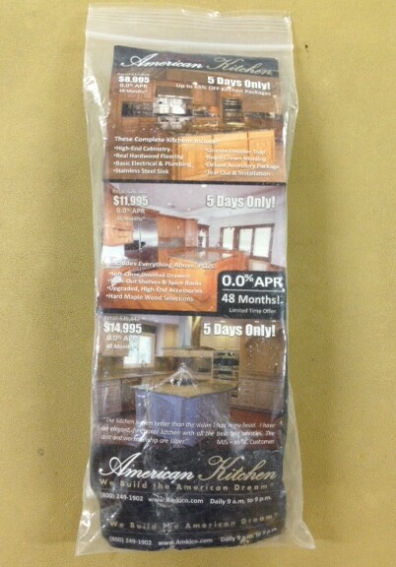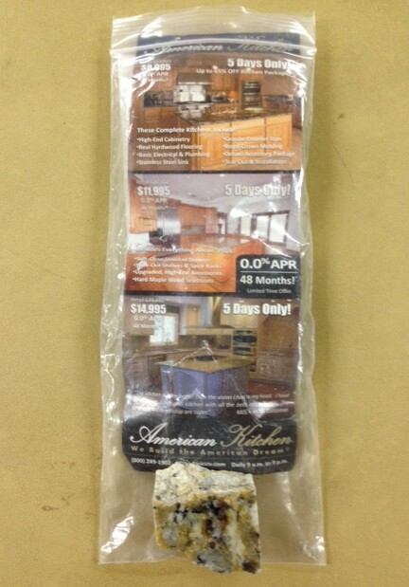
Granite chunk placed inside plastic bag and tossed onto driveways, curbs and some ended up in drains.

Rose Garden Work Morning
On February the 23rd, 2013, at 10 am work will take place on the Rose Garden at Madison Central Park. Bring your own tools, prune, weed, and prep the garden for spring. One winter prune has already been completed by resident Nicole Freeman. Thanks for taking on that task. Councilman Dulin had e-mailed President Doss a couple of weeks ago to state he had come over to work on the garden. He found it had already been trimmed. This effort on the 23rd will be the final prep for spring. Matt Magnasco volunteered at our HOA board meeting earlier that evening to head the spring and fall Madison Central Park Clean up days.


Major support provided by the
City of Charlotte Neighborhood Matching Grants Fund

Our Madison Park Current CMPD / Auto Cling Grant
On Friday 2/8/13 the order was delivered to VP Means and Secretary Means home. We have spoken with Wedgewood Church and were able to book space this Saturday Feb. 16th, 2013 to assemble the mailing. This will involve stuffing the envelopes, adding 2 clings to each mailing, postage, and address labels. If you are able to help us please send an e-mail to Madisonparkhoa@hotmail.com so we know how many to expect to help get this job done. We have about 24 hours of volunteer time assigned to the project. So make sure that you sign in if you are coming to help. We will work from 9 am until no later than noon. We must be out by noon as the Church will have its Artist Café that evening in the space. We are thinking a dozen to 15 volunteers will be more than sufficient to knock this out. Please help if you are free, but do let us know so we can plan accordingly.

Wedgewood Church Farmers Market
Wedgewood Church is about to launch a Farmer Market on their grounds most likely in the next month. President Doss had suggested to Pastor Ayers that he thought this would be a nice amenity for our community. The church has worked on the idea of the last several months. They are expecting to align with the Atherton Mills Farmers Market as an outpost of that Dilworth market. If you have any ideas or products desired let the church or us know. Members thought it would be a plus for the neighborhood to have the market. It is also a busy intersection so should be successful.

Madison Park HOA Board Meeting 2/11/13
Our board held its first board meeting of the year with the new board members prior to tonight’s HOA meeting.

Treasury Report Lisa Roberts
Checking Account Balance as of today: $2960.06
Payments since January meeting:
· PO Box - $78.00
· Parking garage for Marty’s meeting: $3.00
· Total Payments: $81.00
Deposits since January meeting:
· $80.36 PayPal for 4 memberships
· $200.00 cash/check for 10 memberships
· $113.63 Grant from City of Charlotte
· Total Deposits: $393.99
Membership: January 2013 meeting Cheryl Furr reported 52 paid households for 2013. Those 52 plus the 14 new ones equals 66 Paid Households.
More dues were paid after the meeting.
Open Discussion / Issues / Concerns
None

Adjournment: 8:15pm

