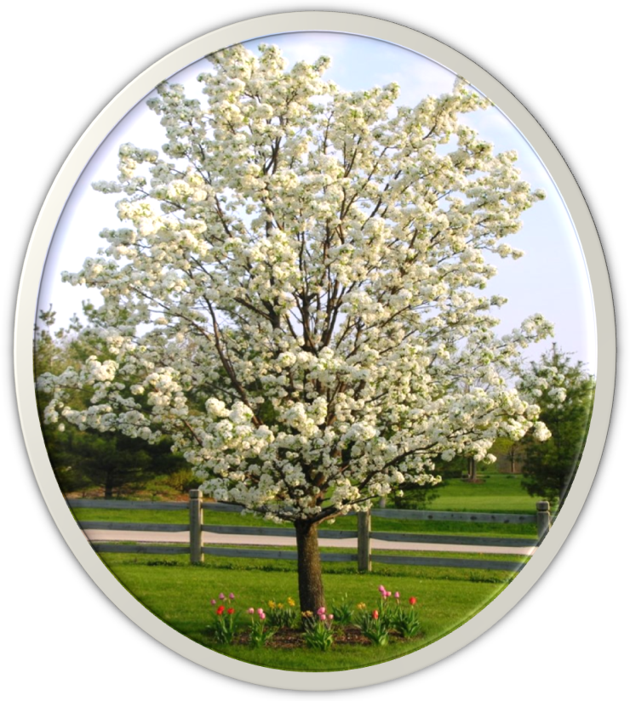
Canterbury Knolls Community Block Club 10 am Saturday April 16, 2011 1826 W. 65th Place
Our Neighborhood Our Voice Our Actions!
YOUR opportunity to make the neighborhood one you delight coming home to!
YOUR forum to express ideas! And YOUR chance to DO something!
Happy Passover, Earth Day and Happy Easter
www.neighborhoodlink.com/canterbury_knoll P.O. Box 470280, Wagner Station, LA, CA 90047
Sponsored by The Canterbury Knolls Community Block Club Contact: Skiffer@usc.edu

