|  |  |
| --- | --- |
| **j0090386BIRCHWOOD/ CLEARVIEW NEWSPublished by Birchwood City-Clearview Manor  Community Association, Inc (BCCA) - January 2017 Edition** | **Birchwood City-Clearview Manor: “A Community That Cares”** Visit us at [***http://www.neighborhoodlink.com/Birchwood_City-Clearview***](http://www.neighborhoodlink.com/Birchwood_City-Clearview) ***or*** [***www.bccaneighbor.org***](http://www.bccaneighbor.org/) ***Email:*** [***bccaneighbor@gmail.com***](mailto:bccaneighbor@gmail.com) |

***IN MEMORIAM***

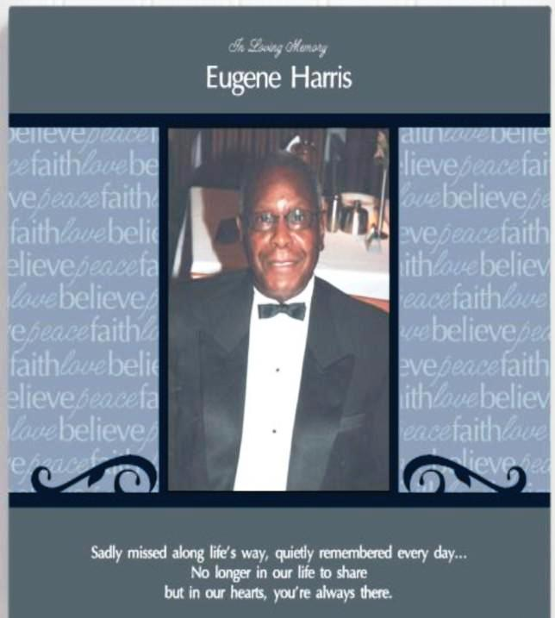

**Mr. Eugene Harris**, a long-time resident of the Birchwood City-Clearview Manor Community and the Neighborhood’s Printer of the Birchwood City-Clearview Manor Community Association (BCCA) Newsletter for many, many years, passed January 7, 2017. He was a great asset to our community--not only dedicating many hours to printing the newsletter but also serving on BCCA’s Executive Board and taking the time to help inform our residents, including our youth. For example, more recently, at a Valley View Elementary School PTA affair recognizing fathers, he created and provided a special certificate to both the fathers and the students as a keepsake so that they could always remember the first inauguration of an African American President. He received a special honor at the BCCA 2016 Holiday Celebration. We dearly miss him.

_________________________________________________________

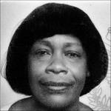**Mrs. Louise McIntosh**, another long-time resident who was very active in BCCA, passed on January 1, 2017. She very seldom attended any of BCCA’s events, but served and contributed in the background. She joined BCCA yearly and kept up with community activities listed in the BCCA News and always donated to BCCA events. In fact, she donated one of the large U.S. Flags used during BCCA’s Community meetings. Before retirement, she always walked to and from the bus stops--always wearing her lovely hats. Many of you assisted her over the years by giving her rides to the local shopping centers and to other appointments she had. We dearly miss her.

|  |  |  |
| --- | --- | --- |
| **WHAT** | **WHEN** | **WHERE** |
| ***BIRCHWOOD CITY/CLEARVIEW MANOR COMMUNITY “BRAINSTORMING” MEETING* AGENDA (1) Making Our Neighborhood Better:** Bring Your Ideas on What You Would Like to See In Our Neighborhood to Improve Things for: -- Our Youth,  --Our Senior Citizens,  --Activities for Youth and Adults at Birchwood Recreation Center,  --BCCA’s Membership,  --The Upkeep of Our Neighborhood,  --Communicating to Residents, --Raising Funds for BCCA,  --Any Other Areas in the Neighborhood  **PLEASE COME OUT TO THIS MEETING.**  **(2) Neighborhood Watch – Prince George’s Police Report** | **Thursday,  January. 19, 2017, 7:00 pm** | **Birchwood Recreation Center** |
| ***C:\Users\User\AppData\Local\Microsoft\Windows\Temporary Internet Files\Content.IE5\AZ17W8BB\pixabella-Valentine-Red-Maori-Heart[1].png*Family Valentine/Love Celebration** | **Friday,**  **February 10, 2017,7:00 pm-10:00 pm** | **Birchwood Recreation Center** |
|  | **Friday**  **March 17, 2017 7:00 pm** | **Birchwood Recreation Center** |

**From the Desk of BCCA’s President** - Rosie Wilson  
**HAPPY NEW YEAR, ONE AND ALL**!! **Boy, wasn't this past year a doozy**? It's a new year and a new season for the Community; and the Association wants to welcome it with open arms as we pick up where we left off in 2016. We were awfully busy last year with Youth Movie Night, Community Day, Clean-up Green-up Day, Fun Night at the Rec, and the Holiday Celebration, just to name a few of the things accomplished last year. **Don't forget, we are still in the 2016-2017 membership year, so don't forget your membership of $20 per year**, per household, which helps the Association do things that will enhance our Community and create, for all residents, things of interest. So, get involved. Come to the meetings, pitch your ideas, and learn what the Association is doing on your behalf. **Hope to see you at our January 19th meeting!!**

_______________________________________________________________________________________________

**From the Desk of BCCA’s Vice President -** Michelle Ross

**Reminder: BCCA’s Warm Coat Drive**! Please donate your **“gently used” coats, or even better, new winter coats and new hats, gloves and socks (for men, women and especially children).** If you want to donate, please bring them to any BCCA event at Birchwood Recreation Center or contact Michelle at 240-441-8447 or e-mail: saphire09@comcast.net. The warm items will be collected between November 15, 2016 and January 14, 2017.

**Reminder: BCCA’s All-Year Food Drive!** Please bring canned food goods or a financial donation to any BCCA event at the Birchwood Recreation Center or call Edith King, Coordinator, at 301-839-4868 or Michelle Ross at 240-441-8447 or email: [saphire09@comcast.net](mailto:saphire09@comcast.net) to arrange for pick-up. **The food will be taken to the Oxon Hill Food Pantry.**

__________________________________________________________________________________________________________

**From BCCA’s Publicity Committee Chair** – Lucy Hall

On behalf of BCCA’s Publicity Committee, we must state how much we miss Mr. Harris. He was our Neighborhood Printer for so many years. We not only miss his work but also the good fellowship we had with him. He was a joy to work with. He was a great team player as are all of the Publicity Committee members. They perform outstanding community service throughout the year. If other residents would like to join us, please call me on 301-839-0499.

_______________________________________________________________________________________________

**From BCCA’s Recreation Committee Chair** - Sylvia Griffin

**BCCA presents its Family Valentine/Love Celebration on Friday, February 10, 2017**

**7:00 pm to 10:00 pm. Music, Dancing, Food and Fun for All at Birchwood Recreation Center!**



Also, BCCA’s Recreation Committee **needs help** and is looking for assistance in helping to coordinate recreational activities for the BCCA community: Need help in planning the upcoming Valentine event and for the March 17th Oldies But Goodies event. If you are interested, please contact me on 240-460-8743.  
__________________________________________________________________________________________________________

**From BCCA’s Education Committee Chair and the Valley View PTA President -** Donald Hanciles

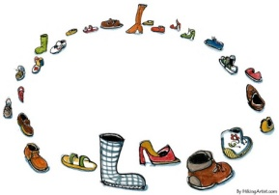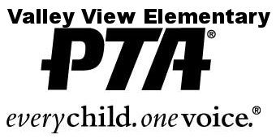

**We Need Your Shoes!! Please Donate Your Gently Used Shoes to Support our**

**Shoe Drive Fundraiser**

Children’s, Men’s and Women’s shoes, sneakers and boots. Please Bring  
Your Gently Used Shoes to Valley View Elementary, 5500 Danby Avenue, Oxon Hill, MD 20745,   
Through March 30, 2017.

***\*Shoes must be clean, in good condition and free of holes with the soles intact.***

***\*\*Shoes are sold to a global reseller***

***Questions: Contact*** [***alewis@abpsi.org***](mailto:alewis@abpsi.org) ***or 240-441-8360***

***If you have a large quantity, we are happy to pick up from your home!***

______________________________________________________________________________________________

Time to Seek Scholarship Money

# C:\Users\User\AppData\Local\Microsoft\Windows\Temporary Internet Files\Content.IE5\X8Q3758N\college-de-paris[1].jpgFor information on scholarships for Maryland students go to <http://mhec.maryland.gov> or [www.mlis.state.md.us](http://www.mlis.state.md.us) or [www.mgaleg.maryland.gov](http://www.mgaleg.maryland.gov). Also, for the Maryland State Senatorial Scholarship, call State Senator Muse at 301-858-3092. Scholarship Applications must be postmarked by May 2017. To qualify for a Senatorial Scholarship, so file the Free Application for Federal Student Aid (FAFSA). This form may be downloaded at <https://fafsa.ed.gov/>. For MD Delegate scholarships, call Delegates: Knott at (301) 858-3212, Walker at (301) 858-3581 and Valderrama at (301) 858-3210

**________________________________________________________________________________________**

**THANK YOU TO OUR COMMUNITY**

**COMMUNITY FAMILY HOLIDAY CELEBRATION: A SUCCESS BECAUSE OF YOU**

Thank You To: Lottie McCoy, BCCA’s Hospitality Committee Chair; BCCA Board members and all of you who helped to make **our 2016 Community Family Holiday Celebration a success**. You helped in planning, shopping, cooking, decorating and serving. You also donated money for the event and canned goods for the local food pantry and you brought warm coats for those in need of them. Lastly, you brought your families to the event. It was truly a “Family Affair” with so many second and third generation families in attendance**. A Big Thank You to the Harris Family and our Great Jolly Santa**, who provided so much joy for our young people and also the adults. **THANK YOU!**

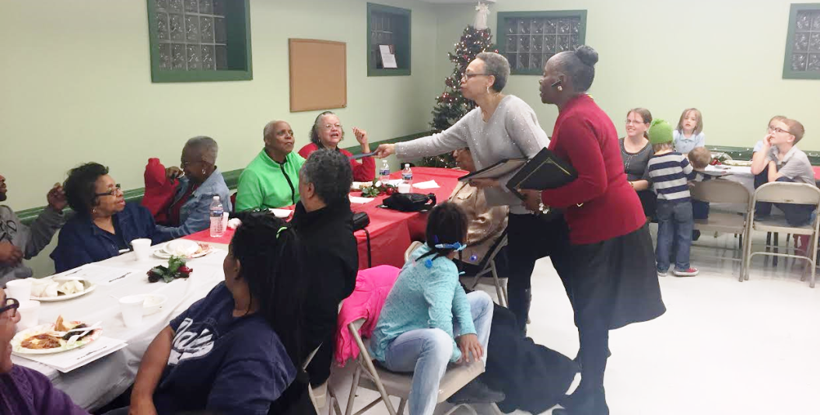

**Fun and Fellowship at BCCA’s 2016 Community Family Holiday Celebration**

______________________________________________________________________________________

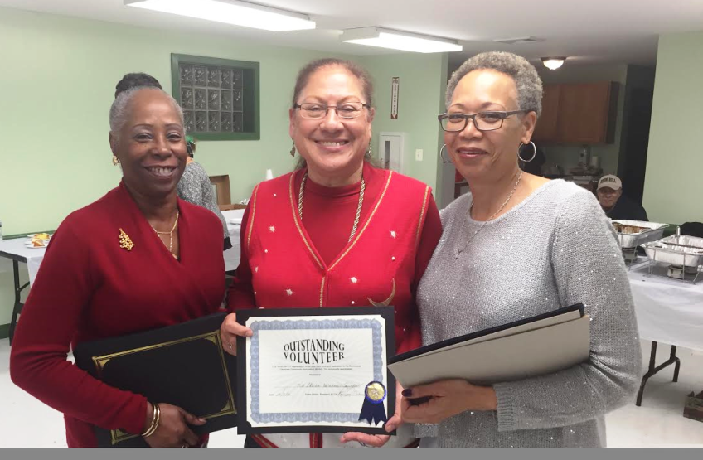

**BCCA’s President Rosie Wilson and Vice President Michelle Ross presenting an Outstanding Volunteer   
Award to Gloria Hernandez Saunders, one of the many volunteers honored at the Family Holiday Celebration. _________________________________________________________________________________________________________________________**

**From BCCA’s Youth Committee Chair** - *Marriner Merrill*

*THANK YOU TO BOY SCOUT TROOP 47 AND OUR COMMUNITY*

**BCCA’s 2016 Boy Scout Food Drive - BIGGEST YEAR YET!!**

Neighbors, in November 2016, BCCA and Troop 47 had their biggest food drive yet.

**We collected 2-3 pickup loads full of food for the Oxon Hill Food Pantry.** That is three times as much as previous years!! **Thank you all so much for your donations.** I can't describe how surprised the food bank was as we just kept bringing in more and more food. They had all their staff putting it away as fast as possible, but we still covered the entire floor area. They were happy to be overwhelmed. There are hungry people in our midst, and it's great to live in a neighborhood that does something about it! **Thanks, too, to Troop 47 for their support of our neighborhood.** We'll see them next November!

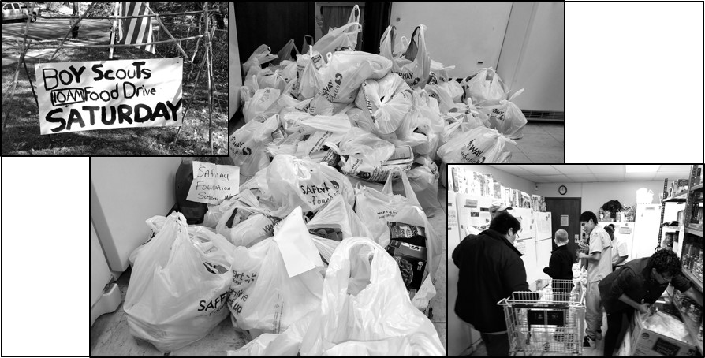As a reminder, food donations are always welcome and we will deliver them to the Oxon Hill Food Pantry. Contact Ms. King at 301-839-4868 for details.

**Food collected by Troop 47 from Birchwood City-Clearview Manor residents and taken to Oxon Hill Food Pantry.**