October 3, 1789
George Washington proclaimed the first National Thanksgiving,

October 5, 1921
The first radio broadcast of the World Series occurred.

October 10, 1959
The first passenger service circling the globe was announced by Pan American World Airways.

October 14, 1912
Theodore Roosevelt was shot from a distance of six feet and wounded, while leaving a hotel in Milwaukee, Wisconsin during his campaign tour. The bullet struck a bulky manuscript in his coat pocket and then entered his chest. Despite the wound, Roosevelt insisted on delivering his speech before going to the hospital.

October 19, 1978
The Concorde SST made its first flight from France to Kennedy Airport in New York, 1978 (The Concorde SST had already begun flights to Washington, D.C., in May.

October 23, 1915
Twenty-five thousand women marched in New York City demanding the right to vote.

October 30, 1776:
George Washington established the U.S. Cavalry.

***************************************

No act of kindness, no matter how small, is ever wasted.

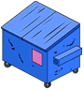
A big shout out to all the residents that utilized the dumpster to get rid of junk and green waste!

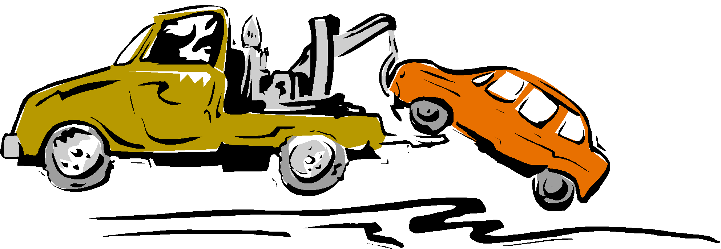
Please be advised that Tow Notices are in full effect for ALL unauthorized parking.
The ONLY authorized parking spaces for your personal vehicles (NOT recreational vehicles) and guests are:
- In your driveway
- Right in front of your home

You are limited to TWO vehicles per household per Park Rules and Regulations. ALL residents/guests occupants have read the Park Rules and signed the Agreement, acknowledging rules would be followed.
Please adhere to all NO Parking areas around the Office likewise.
You are responsible to make sure your visitors understand Park Rules likewise.

Quote of the Month

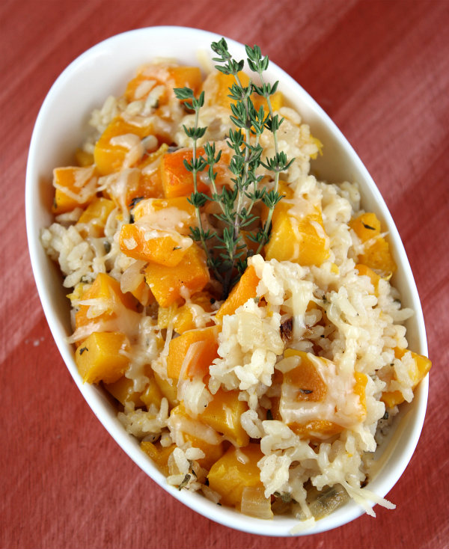
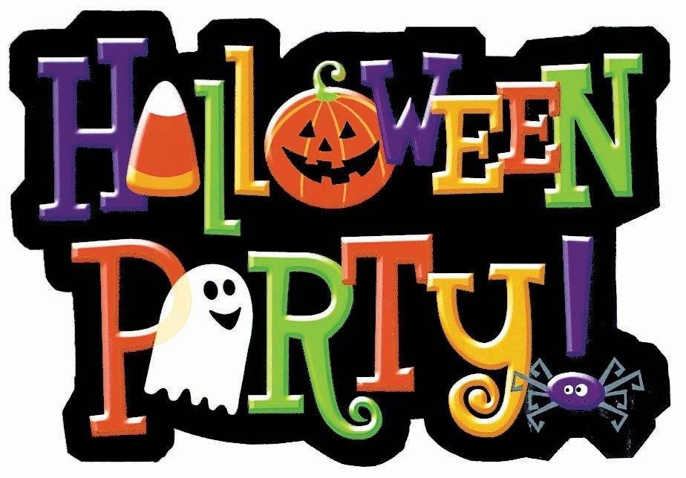
October 31st, 6pm – 8pm (in the gym)
Come join us for:
- Face Painting
- Pumpkin Bowling
- Candy Fishing Game
- Pin the “boo” on the ghost
- Witches Hat Ring Toss
- Gym or Treat
- Bake Sale

If you’d like to donate to the bake sale, please bring items
to the office by 3pm on October 31st.

If you’d like to participate in the Gym or Treat, you are
welcome to bring your candy to the gym to hand out as
the kids are done visiting different activity stations.

Please come in costume!!!
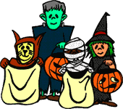

Baked Rice with Butternut Squash

Ingredients:
3 cups chopped butternut squash (about 1/2 large squash)
2 cups fat-free, less sodium chicken broth
1 cup water
1 Tablespoon chopped fresh sage (or 1 tsp. dried rubbed sage)
1 teaspoon olive oil
1 cup diced onion
2 cloves garlic, minced
1 cup uncooked Arborio rice (or other short-grain rice)
1/4 cup dry white wine
1 teaspoon chopped fresh thyme (or 1/4 teaspoon dried thyme)
1/2 teaspoon salt
1/4 teaspoon black pepper
cooking spray
1/4 cup grated fresh Parmesan cheese (1 ounce)
fresh thyme sprigs (optional)

Directions:

1. Preheat oven to 350°F.

2. Place squash on baking sheet and bake for 15 minutes or until
slightly tender; cool. Increase oven temperature to 400°.

3. Bring broth, water and sage to a simmer in a medium Saucepan
(do not boil). Heat oil in a large nonstick skillet over medium-high
heat. Add onion; sauté 6 minutes. Add garlic; sauté 2 minutes. Add
rice; sauté 1 minute. Stir in squash, broth mixture, wine, chopped
thyme, salt and pepper; cook 5 minutes, stirring occasionally.

4. Place rice mixture in 13x9-inch baking dish coated with cooking
spray. Bake for 30 minutes. Stir mixture gently. Sprinkle with
cheese; bake an additional 5 minutes or until cheese melts. Garnish
with thyme sprigs, if desired.

