December 1, 2012
Volume XLIII, Issue 2

Barristers Place Community Association

PO Box 1192 Vienna VA 22183

Email: barristersplaceHOA@gmail.com

The Board of the Barristers Place Community Association voted to maintain the annual dues at $55 for 2013.Please return the enclosed 2013 dues invoice with your contact information and payment. Since the Board uses your contact information to update the BPCA mailing and email records, please indicate if the information is a change from last year. We use e-mail to advise you of timely issues affecting our neighborhood. Your email information is maintained by the Secretary to the Board. This information is not shared or given. The $55 dues are due by January 30^{th.} We would greatly appreciate it if you could send your payment as soon as it is convenient for you. As you know, our Board members are volunteers and while we enjoy the camaraderie at the monthly Board meetings, no one enjoys having to remind a neighbor about a past due fee. We understand that the dues are a once-a- year payment and easy to put to the side. So, as soon as you finish reading this newsletter please pull out your check book and mail in the dues payment to: PO Box 1192
Vienna VA 22183
We thank you for your cooperation.

Highlights

$55 annual dues due
1-30 -13

Annual Meeting:
SAVE THE DATE April 9, 2013
7:30-9pm
Content
Annual Dues
1
Annual Meeting
1
Speeders Cited 1
HOA Website 1
Median Maintenance
2

Volunteers 2
Crime Prevention 2

Date: April 9, 2013
Time: 7:30-9pm.
Location: Louise Archer Elementary Cafeteria
Agenda Items
Please contact the Board barristersplacehoa@gmail.com with items you would like to place on the agenda.
The Board welcomes participation of BPCA homeowners willing to help keep our community a wonderful place to live.
Fairfax County police cited several speeders on Abbotsford Drive in response to complaints by the BPCA board about speeding cars. The posted speed on Abbotsford is twenty five mph
Our neighborhood experiences commuter traffic from drivers trying to escape the congestion on Lawyers Road. We also have speeders on the Marshall Estates side of Counsellor Dr.

Please register on the BPCA website. www.neighborhoodlink.com/vienna/bpca.
Need your BPCA documents?
Our website has links to the documents related to our deeds and covenants. In addition, we post news from Cathy Hudgins, our Fairfax County representative on the Board of Supervisors.

The Annual

Annual Meeting Speeders Cited Barristers’

Save the Date on Abbotsford Website

2013 Annual Dues due by January 30th

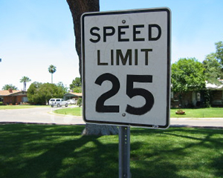
In June 2012, the BPCA Board terminated the lawn service contract with Community Landscape. At that time, the BPCA Board hired Prestige Lawn Service to cut the grass, mulch and prune the entrance shrubbery.
Prestige is owned and operated by two former Barristers Place residents, Dave Shreiner and Tim Badillo. Dave’s mother lives in Barristers Place. Long-time residents may remember Dave cutting grass when he was 12 years old!
While the cost of lawn service dictated the decision to hire Community, the quality and timing of their service was unsatisfactory.
The Board made repeated attempts to have Community cut the grass on a timely basis but was unsuccessful. The cost of lawn care is the major expense for BPCA. The Board considered several lawn service vendors and selected Prestige. Several homeowners commented on the improvement. Please pass along your thoughts to the Board. Our goal is to keep the median strip neat and tidy since it reflects the condition of our neighborhood. Uncut grass and uncontrolled weeds sends a message that homeowners do not care for neighborhood.

New Signs on Abbotsford
Several new speed limit signs have been added to the Abbotsford’s median.
What are the Blue Ribbons?

Blue Ribbons for Jack
Our community mourns 12-year-old Jack Donaldson, who was swept away last September in a Vienna creek's flooded waters. Jack and his family lived in Lawyers North.

I always wondered why somebody didn't do something about that. Then I realized I was somebody.
--Anon.”
Last December, one BPCA home experienced a robbery while the family was asleep and another had an attempted break-in.
Please remember to lock the doors of your house and your car. Keep an outside light burning to discourage prowlers.
In the unfortunate event that you experience a robbery, after you have notified the police, please advise the BPCA Board. We will send out an email to warn neighbors...
If you will be out of town, ask your neighbors to keep an eye on your house, put some lights on a timer and make sure that your mail and newspapers are picked up.
Barristers Place contains 155 homes. Six people serve on the Board. If the remaining 149 households volunteer a few hours a year, everyone in Barristers Place benefits. Have you wondered why our community doesn't have:
- An annual social event
- A babysitting Co-Op
- An annual Park Clean Up
- A Book Club
- A Bunko Club
- A written history of the Barristers Place community.
- A House and Garden tour showcasing changes to the original plans
- A BPCA Garden Club
- A list of those who wish to work as mothers’ helpers, babysitters, dog walkers, etc.
Please volunteer, the Board is happy to act as a clearing house to connect volunteers with each other. Don’t be limited by the above list. Any and all ideas are welcome.
Are you a Project Management Professional (PMP)? Did you know that volunteer activity, including serving on an HOA board, may earn credits (PDUs) for your certification?
Do something for yourself and your neighborhood today!

Median Strip: Abbotsford Drive

Prevent Crime in Barristers Place

Volunteers Needed in Barristers Place

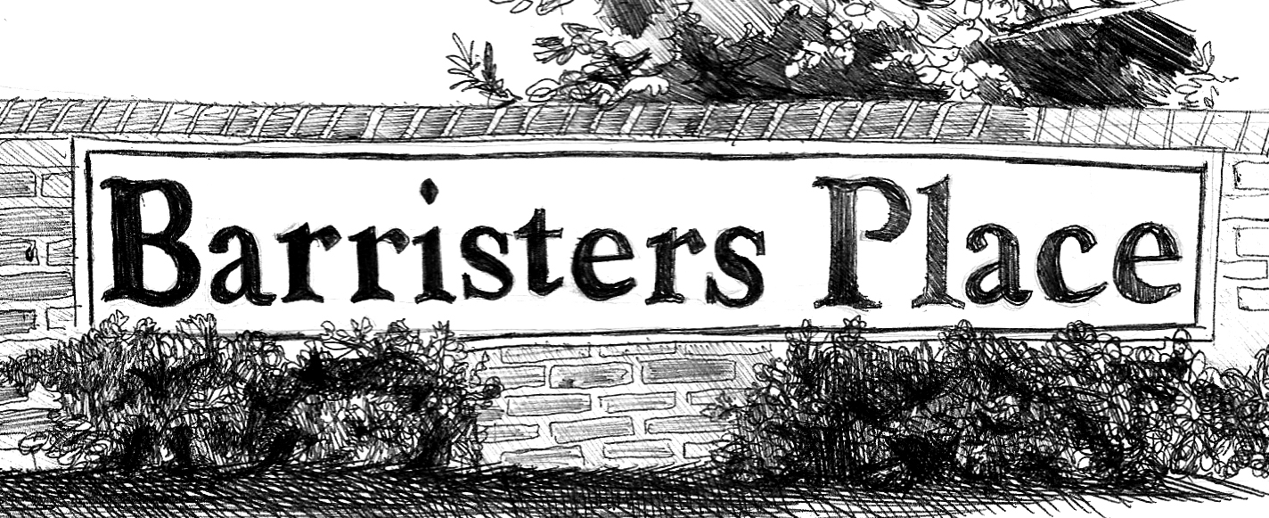

PO Box 1192

Vienna VA 22183

DUES

INVOICE

Do Not Forward

