

The Far East
Neighborhood
Pride Center’s

Providing excellence in the delivery of City services to achieve strong, safe, healthy neighborhoods
May 18, 2011

Neighborhood Notes




Save the Date(s)!
Far East Side Events
You’ll Want to Attend:

May 18, SOAR hire! Youth Job Expo, pre-registration required:
http://www.cowic.org .

May 18, 6:30PM, National Night Out Planning Committee Meeting at the Pride Center.

May 18, 7PM, Countryview Block Watch Meeting, at Pride Center.
jpoole @ columbuspolice.org

May 19, 10AM – 2PM, FREE Dia-betes Screenings at Blacklick Park. www.diabetesohio.org

May 20, 9AM – Noon, $5 Rabies Vaccinations for Pets at Alum Creek Shelter, 1731 Alum Creek Rd. Pets mush be leashed. http: //www.myfcph.org/rabvac.php

May 28, 10AM – Noon, Waggon-er Corridor’s Safety Town Day, Eastpointe Christian Church.

June 2, 6PM, Chase Career Open House, 1111 Polaris Pkwy, RSVP required by May 31st: chase. recruiting@chase.com

June 7, 5-7PM, Meet Your City Council Members at Barnett Rec .

June 11, 9AM, 5th Annual Farm Fresh 5K All Terrain Run/Walk at Shepherd’s Corner. 866-4302.

Neighborhood Pride Team
AARP Administrative Asst.:
Cheryl Byrd, Emily Gorman,
Janice Spruiel
Americorps*VISTA:
Cynthia Louis, CGW
Asst. City Attorney:
Jaiza Page
Center Manager/Liaison:
Lynne LaCour
Code Enforcement:
Kelly Collins, Janae Crawford, Jeremiah Evans, Lisa Manley, Hank Patterson
Columbus Public Health: Rubye Redd, Social Worker
Lauren Rose-Cohen, RN
Nurse Volunteer:
Pat Roush, LPN
Safety/Police:
Jarrod James, 9th Precinct
Garey Scott, 14th Precinct
James Poole, 20th Precinct
Solid Waste/Refuse:
Joe Collins

Meet City Council Members, Tuesday, June 7, 5:30–7:30 PM
Barnett Recreation Center, 1184 Barnett Road

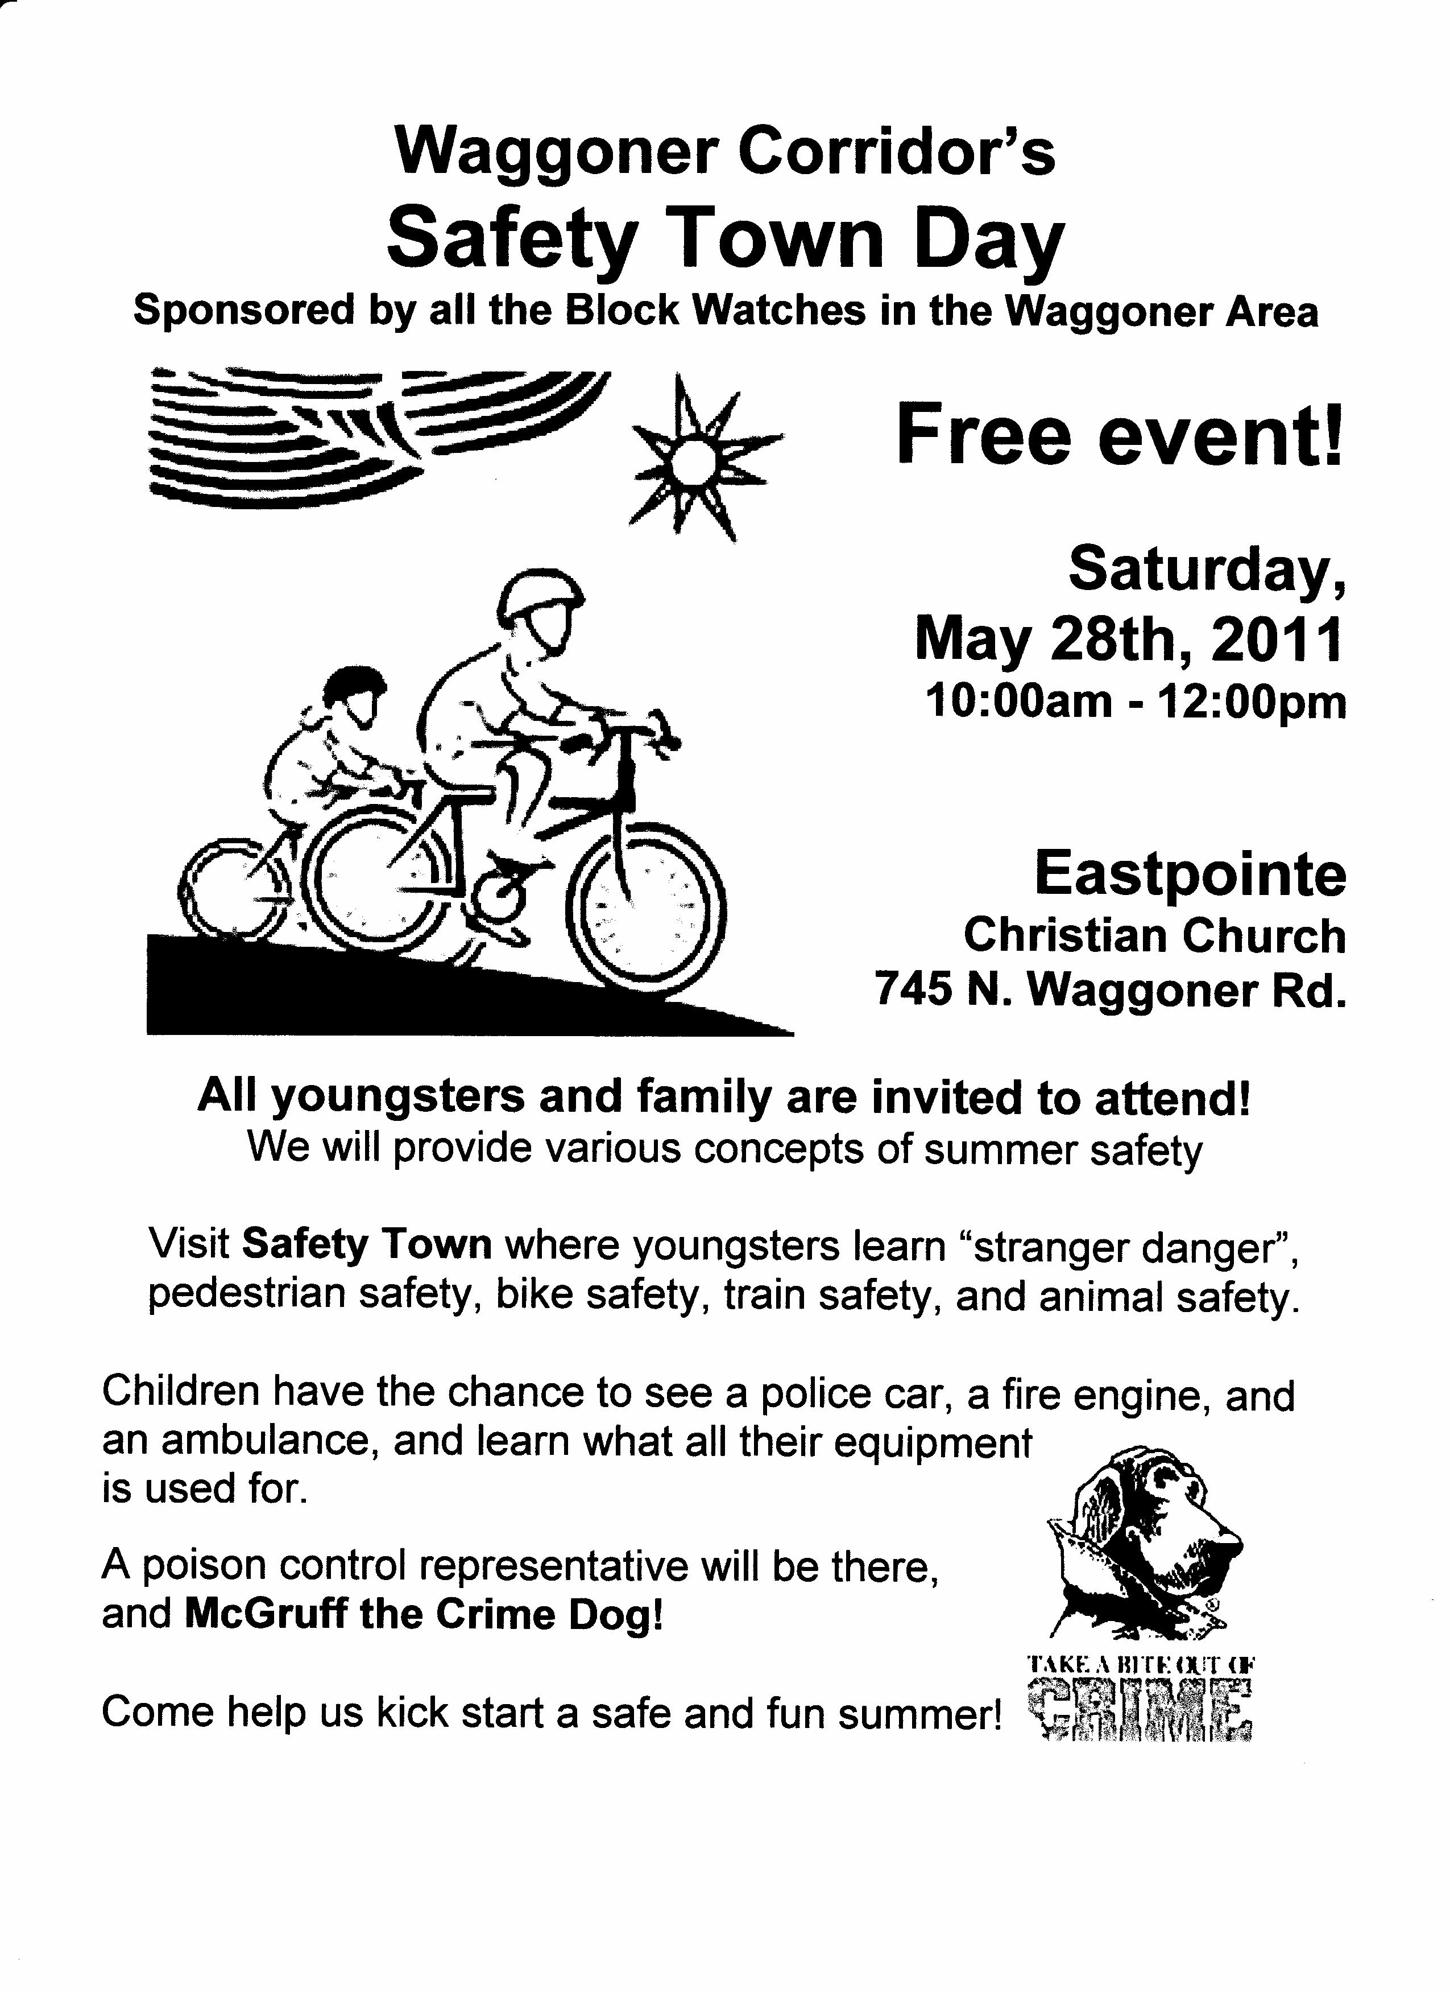

Eastmoor
Academy’s
Impact Team
Wins Service
Award, 2nd
Year in a Row!
Congratulations to the Eastmoor Academy Impact Team on being chosen Top Community Service Group in the City for the second year in a row by the Columbus Rotary. The Impact Team has created a culture of giving and com-munity service, with over 350 student members. Well done!

Neighborhood Notes is a publication of the Far East Neighborhood Pride Center,
2500 Park Crescent, Columbus OH 43232 / Phone: 614-724-0100 Fax: 614-724-0111
You are receiving this email because you have requested to be on our list of email recipients. If you have news items that would be of interest to people living or working on the far east side of Columbus, please email them to cylouis@columbus.gov, or snail-mail to: Cynthia Louis, Far East Neighborhood Pride Center, 2500 Park Crescent, Cols, OH 43232. Archived copies of Neighborhood Notes are available online at http://www.neighborhoodlink.com/Far_East_Neighborhood_Pride_Center/info. If you would like to be removed from our email list, please send an email to cylouis@columbus.gov with the word “Unsubscribe” in the subject line. Thank you!


Gardening Grants
Win $250 for your
community garden
story: http://www.communit ygarden.org/docs/ACGA-ObesityRFA.pdf or win up to $20K for your garden: http: //garden.robertmondavi.com

Last Chance for CNC Grants!
Get up to $1,000 for your community group, no 501(c)(3) required! Deadline May 31st!
Call 724-0104 or email cylouis @ columbus.gov to get an application or help filling it out.


The results are in …
the first round winners
of the CNC Grants
have been announced,
and several Far East groups have won awards! Email cylouis@columbus.gov to get a list of winners!








Ginikanwa Freedom School
June 20 – July 29 at CORPOI
Applications are now being ac-cepted for middle school aged kids for the Ginikanwa Free-dom School Summer Program to be held weekdays at First Church of God, 3480 Refugee Road. Call or email Mr. Willie Wright for details: 231-9564, ext. 261, wwright@corpoi.org


Countryview Block
Watch Meeting
May 18, 7:00 PM
At the Pride Center, 2500 Park Crescent at Alshire Road. Everyone welcome – bring your neighbors! Info: jpoole@ columbuspolice.org




Summer Jobs for Ages 16-24
at CORPOI June thru August
Want to earn money and gain experience? If so, contact Mr. Willie Wright at CORPOI, 231-9564, ext 261, or email wwri ght @ corpoi.org for details.
5th Annual Farm
Fresh 5K All-
Terrain Run/Walk
June 11 at 9AM
…at Shepherd’s
Corner, 987 N. Waggoner Rd. in Blacklick. Preregistration is required, $22-30 for adults, $15 for kids 12 and under. www.shepherdsplace.org


Neighborhood Notes is a publication of the Far East Neighborhood Pride Center,
2500 Park Crescent, Columbus OH 43232 / Phone: 614-724-0100 Fax: 614-724-0111
You are receiving this email because you have requested to be on our list of email recipients. If you have news items that would be of interest to people living or working on the far east side of Columbus, please email them to cylouis@columbus.gov, or snail-mail to: Cynthia Louis, Far East Neighborhood Pride Center, 2500 Park Crescent, Cols, OH 43232. Archived copies of Neighborhood Notes are available online at http://www.neighborhoodlink.com/Far_East_Neighborhood_Pride_Center/info. If you would like to be removed from our email list, please send an email to cylouis@columbus.gov with the word “Unsubscribe” in the subject line. Thank you!
Got Graffiti?
Check out the City
Attorney’s newsletter:
http://www.columbuscityattorney.org/enewsletter.aspx

