



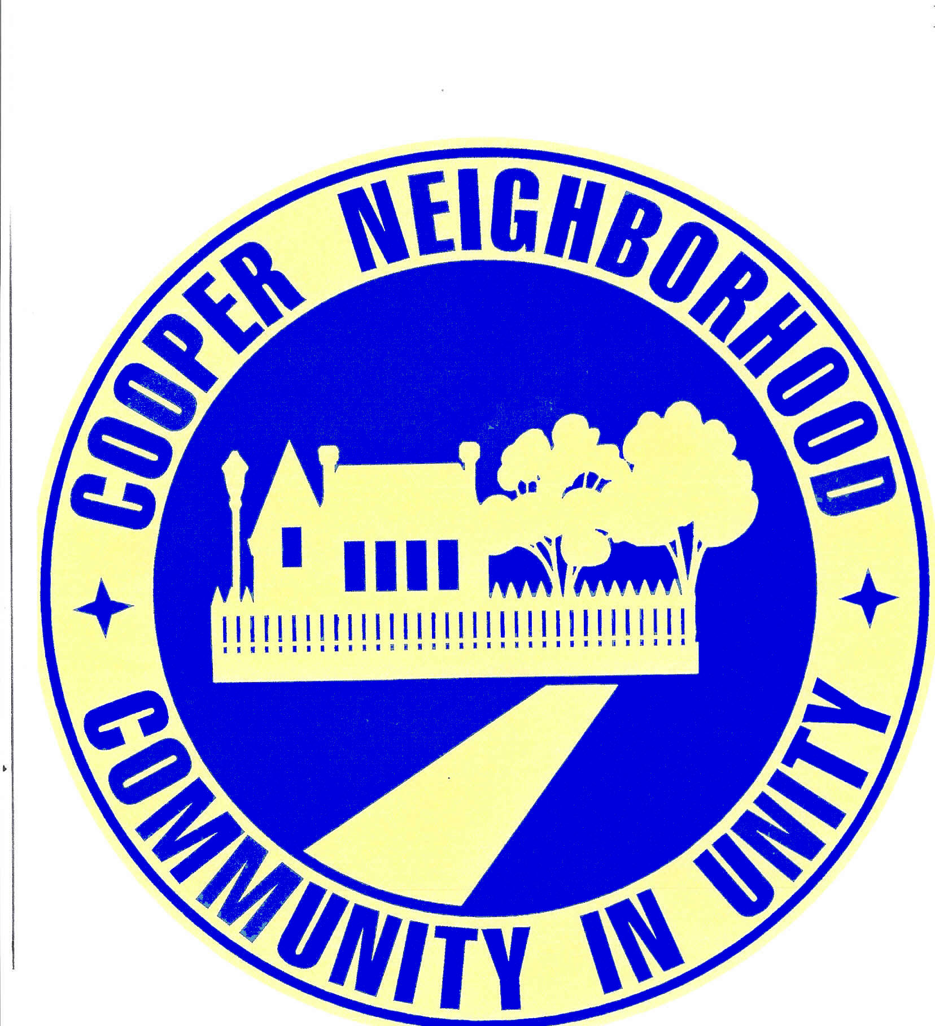



COOPER NEIGHBORHOOD
ASSOCIATION MEETING

MONDAY, MAY 10^{TH –} 6:30 PM

Cooper Elementary School
1808 South 123 East Avenue
(Casual Attire)

Brief Committee Reports

Major Walter J. Evans
Mingo Valley Div., Tulsa Police Dept.

Learn how to spruce up your yard … and our neighborhood. Join us at our May 10th neighborhood meeting.
Our Guest Speaker
will be a Master Gardener

Bring your questions …
and maybe a leaf you don’t recognize

Refreshments & Door Prizes
La Asociación del vecindario de Cooper

Lunes 10 de Mayo, a las 6:30 PM

Gimnasio de la escuela Cooper, 1808 S. 123 E.

MAY 10, 12, 17 & 19

DUMPSTERS
The neighborhood association has once again arranged with the City for dumpsters to be located throughout the neighborhood during the month of May.

Your cooperation in using the dumpsters responsibly will allow us to continue this annual event. Please, no furniture, chemicals, or building supplies.

See page 2 for dates & locations.

MAY 21, 22 & 23
GARAGE SALES
Check out the tips inside for steps to create a yard sale that attracts people and leaves you with some $$$$$ (cash).
While the best yard sales require a lot of work, it's worth it when you count your profits at the end of the day.
The neighborhood will post the sale in the Tulsa World, as well as on Craig’s List. We will also put out some signs in the neighborhood.

SPRING CLEANUP MONTH
http://www.neighborhoodlink.com/tulsa/cooperna Volume 31 May 2010

Cooper Neighborhood Association

N e w s l e t t e r

COOPER NEIGHBORHOOD ASSOCIATION BOARD

President: Pat Kendall

640-2578 patkkendall@gmail.com
Secretary: Nancy Troyer
438-2569 mauibabe7@cox.net
Treasurer: Bill Shannon
437-4897 wshannon1@cox.net
Advisor Emeritus: Tom McBay
(1930 – 2010)
Newsletter Editor: Sue Lawrence 437-5224 SueLawrence@cox.net

Zone 1 - Garnett to S. 121 E. Avenue between 15th & 21st
Misty Blevins 734-4740 CNAPresident@gmail.com
Zone 2 -S. 121 E. Ave. to S. 129 E. Ave. between 15th & 21st
Zone 3 - S. 121 E. Ave. to S. 129 E. Ave. between 11th & 15th
Catherine Thompson 439-9678 catherit176@cs.com
Zone 4 - Garnett to S. 121 E. Ave. between 11th & 15th
Zone 5 - S. 129 E. Ave. to S. 137 E. Ave. between 15th & 21st
Aura Beck
pookie74112@msn.com
Terri Ryan 437-8293
summerstone@greystone.com

Zone 6 - S. 137 E. Ave. to S. 145 E. Ave. between 14th & 21st
Jeff Mundale - 895-8044 JeffLisaM@cox.net

Zone 7 - S. 137 E. Ave. to S. 145 E. between 11th & 14th

Pat Kendall 640-2578
patkkendall@gmail.com

Zone 8 - S. 129 E. Ave. to S. 137 E. between 11th & 15th

DUMPSTER DATES & LOCATIONS

May 10
Zone 1: 17th & 121 E. Ave.
Zone 2: 18th & 124 E. Ave.

May 12
Zone 3: 12th & 124 E. Ave.
Zone 4: 15th & 115 E. Ave.

May 17
Zone 5: 18th & 131 E. Ave.
Zone 6: 20th & 140 E. Ave.
May 19
Zone 7: 12th & 138 E. Ave.
Zone 8: 14th & 135 E. Ave.

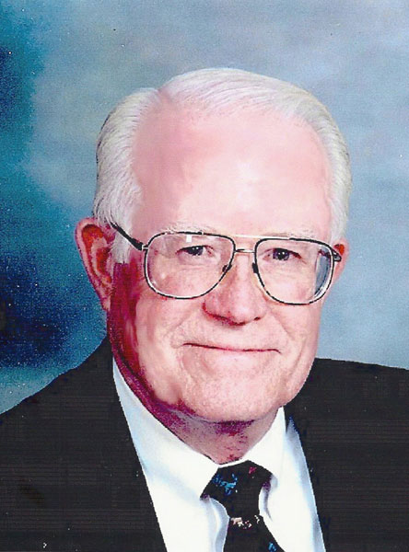
REMEMBERING TOM McBAY

We are saddened by the recent death of our neighbor
and good friend Tom McBay.

Based upon his belief that neighborhoods should
function like small communities, with everyone
working together for the common good, Tom met with a handful of like minded individuals in 2002. Soon after, Cooper Neighborhood Association was organized.

Tom was elected as the first president of the association and thereafter served an active role on its Board in the role of Adviser. He continued to share his vision that an organization should be more inclusive and encompass everyone (not just the homeowners), including the businesses, schools, churches, and other organizations that influence people’s lives.

Although Tom will always be remembered as the founder of Cooper Neighborhood Association, his legacy is so much more.

Through Tom’s leadership we learned how to work together as an “organized voice” in addressing neighborhood issues and concerns with the City. He inspired each of us to do more than we ever thought we could. And, more importantly, he became our valued neighbor and friend.

The Tulsa City Council recognized Tom last July for his volunteer work with Cooper Neighborhood as well as for his volunteer leadership with other East Tulsa organizations.

Tom is survived by his wife Beth McBay and children Karen McBay, Tom McBay, Susan McBay, Ann Francis and one grandson.


NEIGHBORHOOD CLEANUP

A neighborhood that takes pride in its appearance helps maintain property values and also serves as a deterrent to crime.

Let’s take advantage of this beautiful spring weather to spruce up our neighborhood. It’s a great time to do a little extra work in our yards … clearing away old leaves or debris, pruning overgrown bushes, mowing and edging our yards. (Be sure to attend our May 10th meeting where a Master Gardener will be giving us some good tips.)

Sometimes we get complacent about our home’s appearance. Drive by your own home and check out its street appearance. Need some minor repairs, or a bit of paint? Maybe its time to replace those sagging blinds. Or, perhaps you have some large items you’ve been meaning to get rid of. If so, call the City’s Bulky Waste Pickup and they will pick up those items for FREE. Call them at 596-9777.

Consider helping an older neighbor with some of their chores or picking up the yard of a vacant home in your area. Working together, we can make a real difference in our neighborhood.





COOPER NEIGHBORHOOD
CRIME PREVENTION

Greetings again to the residents of Cooper Neighborhood Association.

Finally spring is here and, with it, we are seeing the normal up-swing of human activity. Families are beginning to get out more often and their homes and property are more vulnerable.

We encourage all residents to be aware of evaluating your home or apartment's security and be sure that all doors and windows can be locked or secured when you and your family members are away. Side garage doors are often quite vulnerable to residential burglaries and, believe it or not -- are simply just not locked by their owners.

Also, I know this sounds crazy, but please just check your garage door (if you have one) each night before going to sleep; just make sure it is closed and locked. We are seeing that on several occasions that the "bad guy" simply has walked into a victim's garage and/or interior of the home and takes whatever is nearby or what is wanted.

Please always be on the look-out for yourself & family members. Again, as I mentioned last time, always call 911 - if you notice anything suspicious in your neighborhood area. We definitely need your eyes and ears when unusual, "out-of-the ordinary" things are occurring.

Again, have a safe and sound spring and summer.

Sgt. Ted Umbarger - Mingo Valley Division. TPD
THURSDAY AFTERNOON BOOK CLUB

Our most recent book, Brother, I’m Dying, was the memoir of Edwidge Danticat. The author recounted how her extended family was torn apart by the political unrest in Haiti.

On a lighter note, we will be reviewing
Ella Minnow Pea, by Mark Dunn,
at our May meeting.

Interested in attending? Simply drop by Martin Regional Library, check out the book and read it prior to our next meeting.

We meet the third Thursday of each month at 1:30 PM at Martin Regional Library.

We’d love for you to join us.

City ordinance prohibits the
parking of vehicles in yards.

Parking is permitted on residential
lots only on a legal driveway or in
a garage. A driveway or parking area must be made with approved all-weather surface material (asphalt or concrete) to meet city standards. In certain zoning situations, there are limits to the amount of yard area that can be used for a driveway or parking.

Vehicles parked in the street must be operable and may not remain parked in the same space for an extended time.
Violations should be reported to the Mayor's Action Center at 596-2100.

When reporting a street parking violation, please note the closest address, the color, model, and tag number of vehicles.

SUCCESSFUL
GARAGE SALE TIPS

Decide if you have enough items to hold a yard sale (the more the better).
Advertise. Let your family, friends neighbors know. Put signs out. Consider listing the sale on Craig’s List.
Clean your items. No one wants to buy dirty items.
Arrange all items on tables (or whatever you are going to display them on) the day before the sale. Be sure all items will be openly displayed. (Keep tables inside over night.)
Put a price tag on everything, no matter how small. You may want to consider having a sign which reads, 'All reasonable offers considered.”
You may need to get some extra bills for change.
Sale over? Consider donating your unsold, usable clothing and household items to Goodwill, 102 South Garnett Road.

Thank You The McBay family has sent a note of thanks for the expressions of sympathy received upon Tom’s passing.



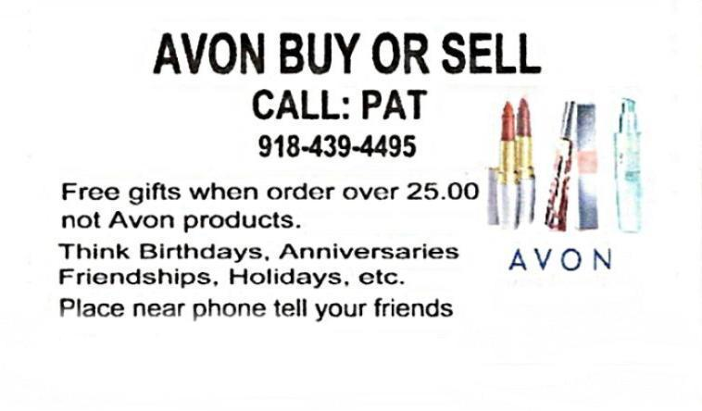
E-Mail: millarrky@cox.net
Special Thanks
to our Advertisers

Speak Your Text & Email Messages
Drive Safe & Keep Both Hands on the Wheel
Demo: www.MyVoiceToText.com
Great Products Unlimited Business Opportunity
Pat Kendall 640-2578





Free Medication Management Workshop and Individual Medication Reviews for
Ages 60 and Older
at Martin Regional Library, 2601 South Garnett
Sponsored by the Tulsa Area Agency on Aging,
OU College of Pharmacy and OU Physicians

The Medication Management Workshop
Wednesday, May 12, from 10 AM - 11 AM
The presentation will give you information about your medications and important tips you should know about how to use your medications safely to prevent problems or side effects. You will also learn important questions you should ask your doctor or pharmacists about your medications. There will be a short period for questions at the end.

Individual Medication Reviews
Wednesday, May 19, from 2:30 PM to 5:30 PM
You will have the option to make an appointment to meet individually for 30 minutes with a pharmacist and pharmacy students from the OU College of Pharmacy and OU Physicians to review each of your medications individually. Bring all of your medications (both prescription and over-the-counter) so the pharmacist and pharmacy students can review them and answer your questions.

An appointment is required. To make an appointment, or if you have questions, contact: Angela Boyd of OU Physicians, 619-4768 or email angela-boyd@ouhsc.edu.
IMPORTANT NUMBERS
EMERGENCY ----------------------------- 9-1-1
NON EMERGENCY ASSISTANCE -------596-9222
MAYOR’S ACTION LINE-------------------596-2100
FREE BULKY WASTE PICKUP ---------596-9777
2-1-1- HELPLINE: 24 hour # to access
health and human service info --------------- 2-1-1
National Assn. of Letter Carriers Food Drive – May 8

● Place non-perishable food products in a bag and leave by your mailbox early Saturday.

● Your Letter Carrier will pick up and deliver to local food banks and pantries.
Sponsored by the NE Oklahoma Labor Council, Tulsa Area United Way and area food pantries

