Bayview Manor Maintenance Corporation
(“BMMC”)
P.O. Box 455
New Castle, DE 19720
bayviewmanor1@gmail.com

May 23, 2019

RE: Snow Removal Services Bidding Process

You have been invited to provide a proposal for the snow removal services for the Bayview Manor I Community. Attached is a request for proposal for this scope of work.

All proposals must be submitted no later than 4:00 p.m. on June 14, 2019 to the following address:

Bayview Manor Maintenance Corporation
P.O. Box 455
New Castle, DE 19720

A mandatory pre-bid meeting is scheduled for June 07, 2019 at 9:00 a.m. at the Bayview Manor I Community Entrance (Eugenia Meadows). All work for this scope of work will be for the 2019-2021 year.

All questions regarding the scope of work should be directed to Tracey Whye of Bayview Manor Maintenance Corporation per the attached Request for Proposals.

Scope of Work:

Bayview Manor Maintenance Corporation (BMMC) is soliciting competitive sealed proposals for snow removal and roadway preparation (salting) services from the entrances off of Route 9 (River Road and Eugenia Meadows and Malcolm Forest Roads) all cross streets in the development (Eugenia Meadows, John Vineyards, and Frank Orchards) and Keller Beyer and Malcolm Forest Roads to Bayview Manor II entrances. The purpose is to provide a guideline for all companies interested in submitting a bid to BMMC.

The contractor will be responsible for furnishing all required labor, equipment, and materials for snow removal in the figures below.

Extra copies of this packet are available on our website: http://www.neighborhoodlink.com/Bayview_Manor_I

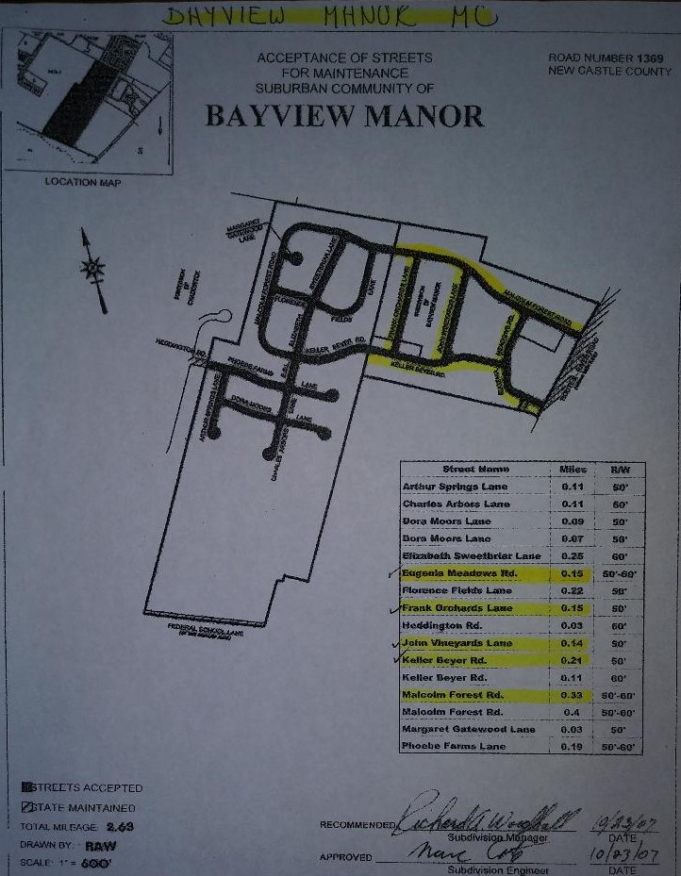
Figure 1
Figure 2

GENERAL:
- The snow removal season will begin 11/1/2019 and end 4/30/2021.
- Contractor and their designated subcontractors must submit copies of business license and liability insurance with the completed bid sheet.
- All drivers MUST be drug free and have proper licensure for the equipment to be used in Bayview Manor.
- Contractor will provide a breakdown of all equipment and prices if bid price is per piece of equipment.
- Contractor will perform a pre-season and spring inspection for damage with a representative of BMMC. Contractor will be responsible for all damages
- The bidding contractor agrees to meet with BMMC representative upon request.
- BMMC reserves the right to cancel all contracts with a 30-day written notice.
- Contractor must submit expected response time to all calls from the President or designated Board Member.
- Contractor must submit expected response time to arrive on site after activation.
- Plowing is to be performed when contacted or the accumulation reported on www.snow.deldot.gov New Castle County Zone 10-Bear as DelDOT’s official measurement reaches three (3) inches.
- Roadway Preparation (salting road surfaces) shall be approved by the Maintenance Corporation prior to vehicles dispatched.
- Contractor shall make the most cost-effective usage of his vehicles while performing snow removal when dispatched.
- Contractor shall mark all curbing through the designated areas of the development.
- All prices are the same for all days including Saturday, Sunday, and Holidays.
- Residents will make every effort to remove their vehicles from the streets prior to plowing. Contractor will not be responsible for plowing in parked cars or driveways, but will be responsible for damage caused by the snow plow and/or vehicle(s).

The following roads will be plowed for two-way traffic are as follows: (see Figures 1 & 2 above for Map)

Road Number Name of Road Length of Road
139273 Eugenia Meadows Road 0.19
139309 John Vineyards Lane 0.14
139315 Frank Orchards Lane 0.15
139324 Keller Beyer Road (stop where sidewalk starts) 0.21
139272 Malcolm Forest Road (stop where sidewalk starts) 0.33
TOTAL: 1.02 mi

The Contractor is responsible to perform all work in accordance with EPA, State of Delaware and local requirements including but not limited to snow removal. The Contractor will make every attempt to clear all the roadways of snow and ice.

Pre-Proposal Meeting:

BMMC will hold a pre-proposal meeting at 9:00 a.m. on June 07, 2019 at the Bayview Manor I Eugenia Meadows Entrance, New Castle, DE 19720. Attendance at this meeting is mandatory.

Tour of Site:

Site tours will be schedule immediately following the Pre-Proposal Meeting.

Question Period:

BMMC understands that prospective contractors may have questions. All questions should be in written form and received before 4:00 p.m. on Friday, June 07, 2019.

Questions should be submitted in writing to the BMMC, Attention Tracey Whye at bayviewmanor1@gmail.com.

Questions and answers will be distributed to all prospective Contractors by email. Addendums will be issued and distributed as necessary.

Partial Proposals:

Partial Proposals will not be accepted.

Termination of Proposal:

In the event the proposal process is terminated, proposals will be returned to prospective contractors without disclosing the contents.

Submitting Proposals:

Three (3) copies of the completed proposals should be received at the following address or emailed to: bayviewmanor1@gmail.com no later than 4:00 p.m. on June 14, 2019. Proposals may also be submitted through invite in Google Forms, contact BMMC at bayviewmanor1@gmail.com for invite.
Bayview Manor Maintenance Corporation
P.O. Box 455
New Castle, DE 19720

All envelopes must be sealed and clearly marked-BMMC Snow Removal Services. Late proposals will not be accepted.

Review Committee:

The Review Committee will review and rank the proposals. After the Review Committee has reviewed the proposals, the committee may request verbal presentation by one or more contractors.

Selection and Contract Negotiation:

Following the review process, the Review Committee will make a recommendation to the BMMC Board to either select a contractor’s proposal or to reject all proposals and terminate the process. BMMC make its determination as to the most appropriate response to the proposals and may award the contract to the successful proposer. If unable to complete and execute a contract with the selected contractor within thirty (30) days, BMMC reserves the right to extend or suspend the negotiations, or begin negotiation with another contractor, or terminate all negotiations.

BMMC reserves the right at any time during the proposal process to reject, combine, divide or modify any or all proposals. Modifications of the scope may involve the elimination and/or withdrawal of one (1) or more components of the RFP from consideration. Modification of the project may also involve awarding only a portion of the scope of work.

Notifying Unsuccessful Contractors:

BMMC will notify unsuccessful contractors at an appropriate time.

Selection Criteria:

The general selection criteria used in evaluating the proposals will include, but shall not be limited to, the following:

- The contractor’s over all qualifications
- The contractor’s ability to satisfy BMMC’s objectives outlined in the RFP
- The contractor’s ability to provide the services outlined in the RFP
- The fees, costs, and expense associated with the proposals

Cost is very important to BMMC; however, it is not the controlling evaluation factor. However, among equally qualified contractors, cost will be the controlling evaluation factor.

Qualification of Contractors:

No proposal will be considered from any contractor unless he is known to be skilled in work of a similar nature to that covered by the contract and has sufficient cash capital to meet all obligations to be incurred in carrying out the work. BMMC will make investigations as deems necessary to determine the ability of the contractor to perform the work and contractor shall furnish to BMMC all such additional information and data for this purpose as BMMC requests.

BMMC reserves the right to reject any proposal if the evidence submitted by, or investigation of such contractor fails to satisfy BMMC that such contractor is properly qualified to carry out the obligations of the contract and to complete the work contemplated therein, but failure to reject shall not be considered proof of such contractor’s qualifications.

The Contractor shall provide, in writing, the name, addresses, and phone numbers of at least three (3) references for projects involving similar work.

Subcontractors:

The Contractor shall provide, in writing, the names and addresses of all subcontractors to be used. BMMC reserves the right to exclude the use of any or all subcontractors named.

Substitutions and Alternatives:

Any scope alternatives shall be detailed in writing. BMMC reserves the right to refuse any or all alternatives.

Invoicing:

The Contractor shall provide on the invoice the breakdown for each snow event to include service work performed, quantities of materials, date, time, and equipment utilized to perform the scope of work.

Scope Growth:

NO WORK shall be performed outside the current scope of work without written authorization and approval from the BMMC board or designated representative. All additional work shall be submitted with an estimated lump sum costs, brief description, quantities of materials, date, time, and equipment utilized to perform the work.

Insurance:

The Contractor shall provide proof of insurance including a comprehensive liability insurance policy. Prior to beginning of work the successful contractor will name BMMC as co-insured for personal injury and/or property damage.

Indemnity:

The Contract between BMMC and the Contractor shall contain provisions to indemnify and hold harmless BMMC and its officers from any loss or liability for claims, damages, or lawsuits for reasons resulting from acts or omissions by the Contractor or its agents during the term of the Contract.

Payment:

The payment schedule will follow the order of tasks as detailed in the next section. Payments will be released following the successful completion of each of the major tasks.

REQUIRED SECTION:
Bayview Manor Maintenance Corporation
Snow Removal Services Bid Form
2019-2021

Contractor: _________________________________________________________________
Address: _________________________________________________________________
_________________________________________________________________
_________________________________________________________________
Primary Contact: _________________________________________________________________
Phone: ______________________________________________
Fax: ______________________________________________
E-mail: ______________________________________________

Accumulation totals based on DelDOT measurements for New Castle County, Zone 10-Bear.
Cost of snow removal from roadways, curb to curb, per storm:

Rates:
Under 4.0” $______________________
4.0” to 7.99” $______________________
8.0” to 11.99” $______________________
12.0” to 15.99” $______________________
16.0” to 19.99” $______________________
20.0” and above $______________________
Salt $______________________
Sand $______________________
Landscapers Choice $______________________
Ice Melt 40 lb/bag
Community Salt Mix Barrel $______________________
Approx. 350 lbs
Refill of Barrel $______________________

Bayview Manor Maintenance Corporation Contractor: __________________________
Signature of President: _____________________ Contractor signature: __________________
Date: __________________ Date: __________________
Comments:___________________________________________________________________________
_______________________________________________________________________________________________________________________________________________________________________________________________________________________________________________________________

