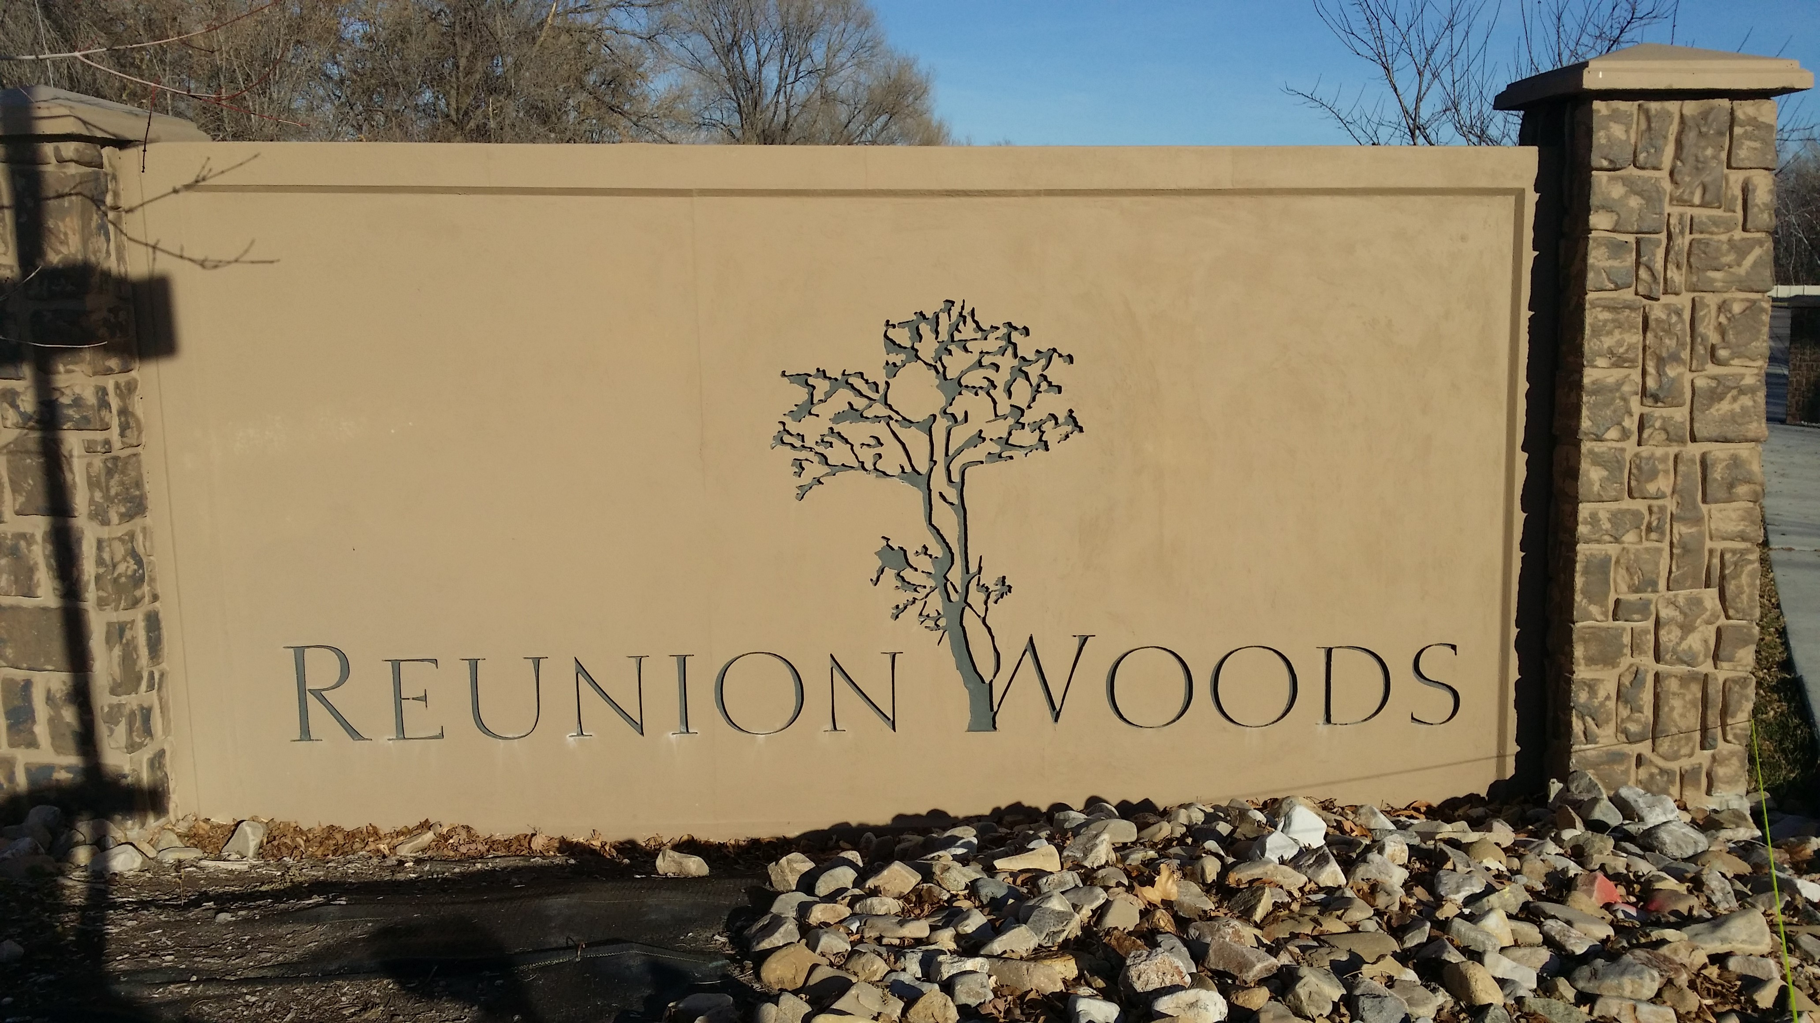

Reunion Woods HOA Newsletter

Greeting…and Happy Spring! Even though we desperately need the water, this winter has been very kind to Reunion Woods. For all practical purposes, spring started several weeks ago. The mild winter means we spent less than planned for snow removal which has helped our financial picture. We are currently “in the black” as far as income vs. expenses. We don’t have a lot of money, but we have enough to pay our current expenses.

With the coming of spring, there is a great temptation to plant something. Please remember that any changes to the landscape need approval of the HOA Board. The exception is if you would like to plant spring bulbs. All other shrubs and plants need to be approved before you buy and plant. As a board, we want to make sure we maintain the integrity of the landscaping and to be sure we plant water-wise plants. If you want to make any changes in the landscape around your unit, including “hard scapes”, please submit that request in writing to any member of the Board. We will make every effort to respond to you within 48 hours. In the meantime, enjoy the sunshine and the beautiful blossoms around the neighborhood!

Newest residents
Our newest Reunion Woods residents are Richard and Erma Brock. They have moved into the unit most recently used as the model. They have recently moved from Moab, but still maintain a home there. Richard loves to garden and plans to keep one going in Moab. Please take an opportunity to get acquainted with them.

Our next door neighbor on the west
Our neighbor on the south of Reunion Woods is Fred Albert. Some of you have met him and found out what a nice person he is. Fred and his family have been there for many years. Fred has endured the noise and the dust of Reunion Woods construction without complaint. Soon, he intends to start a project of his own. Once he has obtained city approval, he intends to build three homes on his property: one for him and his wife, one for a daughter and one for a son. As he builds, we need to be as patient and tolerant of him as he was of us. We are fortunate to have such a good neighbor.

Reunion Woods Website
Frank Wilson is developing a website. Check it out: http://www.neighborhoodlink.com/Reunion_Woods_Home
Water Use
Utah is the second driest state in the United States. We need to be wise in the way we use water. As you probably know, the HOA pays the bill for the water—inside and out. In 2014, we had budgeted $5,070 for water. We were shocked to find that we actually spent $9,395.10! Part of the cost was due to excessive watering of the grass. We think we have that solved for 2015. However, each of us needs to remember that we ARE the HOA and we are paying for the water.

Here are some water-wise things we can do:
- No washing of cars on the property. Instead, use a local car wash.
- No washing down driveways or sidewalks. Instead, use a blower or broom.
- Don’t hand water plants unless they need watering. There is still plenty of water in the soil to take care of their needs for another month. Water if plants start to droop. The biggest plant problems in Utah come from over-watering, not under-watering. If plants are watered too often, they will not produce a good root system, and the plants will be less healthy.

An article in the Deseret News of March 21, 2015 recommends that watering should start about Mothers’ Day. That’s right—Mothers’ Day. That forces the grass roots to grow down to where they can reach the water and builds a stronger lawn. Delaying water use not only helps the lawn but will save us money. We will work with the landscape company to insure wise use of our water.

Last week, ProGreen began their summer work. They will soon begin mowing the lawns. They have been instructed to set the sprinklers to conserve water, and will not start watering for a couple of weeks. If you have any issues with the landscape people, please contact a member of the Board and we will address the problem with ProGreen.

Bulletin Board
A new bulletin board has been installed near the entry way. It is for the use or Reunion Woods residents. From time to time, we will insert notices, including copies of the news letter. If you have any questions about what is proper, please talk to Maxine.

Project Update
Here is the latest on the projects Jeff Mansell is working to complete.
- Branches overhanging Building 5 have been removed.
- Holding pond level has been raised: working to complete.
- Mansell signs have been removed.
- Dead shrubs and grass to be replaced soon.
- Replacing broken cement: yet to be completed.
- Front gate: scheduled for installation the week of April 20th.

HOA Board Meetings
We have scheduled the following dates for Board meetings: April 13, June 8, August 10, and October 12. Meetings are usually held at 2:00 P.M. at Snelgrove’s. All residents are welcome to attend. If you plan to attend or have items you’d like to discuss, please let us know in advance of the meeting.

Mulch Replacement
Building Four has received approval to remove the bark and replace it with rock. It will match the rock color at Lyle Fangmeier’s home (5514 Reunion Woods Court). The individual home owners (NOT the HOA) will bear the entire expense. Anyone wishing to do the same can submit a written request to a member of the Board. Because we are a planned community, the options are limited to the dark bark or matching pink rock.

