The Brittany Hills Civic Association held a Board of Directors Election on January 16, 2014 for the offices of President, Vice-President and Secretary.
A special Thanks go to our outgoing officers: Marvine Germany, Alfonso Hooper and Mamie Toland-Good for all of their hard work.

Welcome and Congratulations to our newly elected officers:

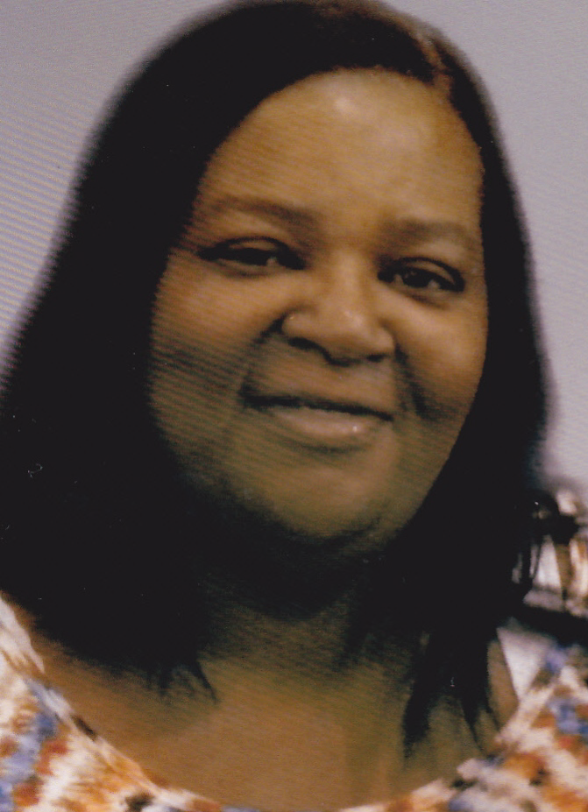

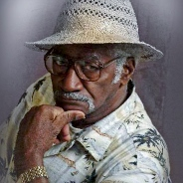

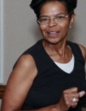

Shelia Tillman

President

Ms. Tillman grew up in Brittany Hills. She brings a fresh perspective to the Civic Association, with the Courage, Drive and Passion to make positive changes that will enhance the community.

Morris L. Chisholm, Sr.
Vice-President

Mr. Chisholm is a long established resident of the Brittany Hills neighborhood. He has been a champion for community causes and deeply involved with the Civic Association on many levels.

Emanuel Sutton-Freeman Secretary

Mrs. Freeman has been involved with the Civic Association for many years and is also a long established resident. She is dedicated to and focused on activities that will move the community forward.

