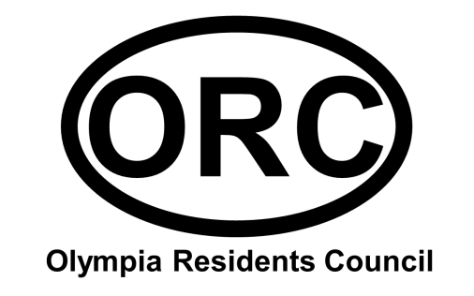

Meeting Minutes

November 20, 2013
Guests / Speakers: | Chief Aubrey Jenkins, CFD; Deputy Kevin Lawrence, RCSD CAT Team; Jami Campbell, USC Good Neighbor Program; Josh Cruse, Columbia Star Newspaper
Next meeting: | 12/18/13, 7:00 pm; 701 Whaley

RCSD CAT News
We welcomed Deputy Lawrence as our new CAT representative, replacing Deputy Hall who has been pulled to work on another effort. He brings an impressive background with him, including selection as the 2001 Deputy of the Year for Richland County. He reminded us to be extra vigilant during the holiday season as they typically see an increase in break-ins & armed robbery around the county at that time. Be the nosy neighbor, and call 911 any time you see anything suspicious going on or anything makes you feel uncomfortable or unsafe. You can also call the 888-CRIMESC tip-line with information regarding warrants or other illegal activity. If you provide your contact information and your tip leads to a conviction, you will be eligible for a reward.

Deputy Lawrence can be contacted via email at KLawerence@RCSD.net or via his cell phone at 803-309-3441.

Fire Station Open House
The open house was a great success with about 30 people in attendance and coverage from WLTX & the Columbia Star. Two of our elected officials were in attendance, and they as well as the community were able to see the obvious structural issues & mold that affect the station. Kids were thrilled by the fire engine, and the crew was very friendly & open.

Chief Jenkins thanked the group for ORC’s part in the event and for showing concern for the station & the firefighters. Engine 2 covers Olympia, USC, and parts of both downtown & Bluff Road. They also assist other teams such as the Rosewood and Devine stations. Of the 30,000 calls per year that the department receives, Engine 2 gets 1500, the majority of which are medical calls.

He shares our concerns about the condition of the station, and a plan to address the quality of life, communications, and general facilities has been submitted. The mold is a particular threat, and an air quality inspection has been requested. He would like to see the existing station replaced with a new one housing not only the fire department but also EMS and possibly a police substation too. The idea of potential assistance from USC Athletics was discussed since the station covers all of the university’s athletic facilities. The truck could even been repainted with garnet & black to honor the Gamecocks. It was recommended that he work with USC’s fire marshal on this.

We also discussed the Adopt-a-Fire-Station program which has met with great success in the Cottontown neighborhood. Their station has become a center of community life, hosting a number of events including their residents association meetings. The station was recently updated, and Home Depot volunteered materials for painting & gardening as well as new lockers. The group pledged our support in any way we can – more awareness efforts, advocating with our representatives, etc. Additionally, we are working on providing the firefighters with a Thanksgiving day meal.

On a side note, the chief recommended that homeowners check with their insurance companies about possible discounts on their policies for being in such close proximity to a fire station.

Other items
USC - Residents shared positive feedback with Jami on the improved atmosphere in regards to our student neighbors. This was accredited to a combination of landlord involvement, an increased law enforcement presence, and the efforts of community members to work proactively with the students in some cases.

Union Hall – A sale is pending on the old Union Hall. Efforts have been made recently to protect the building from use by urban campers as well as from being condemned. Hopes are high that it can be preserved and restored as a feature of the community.

