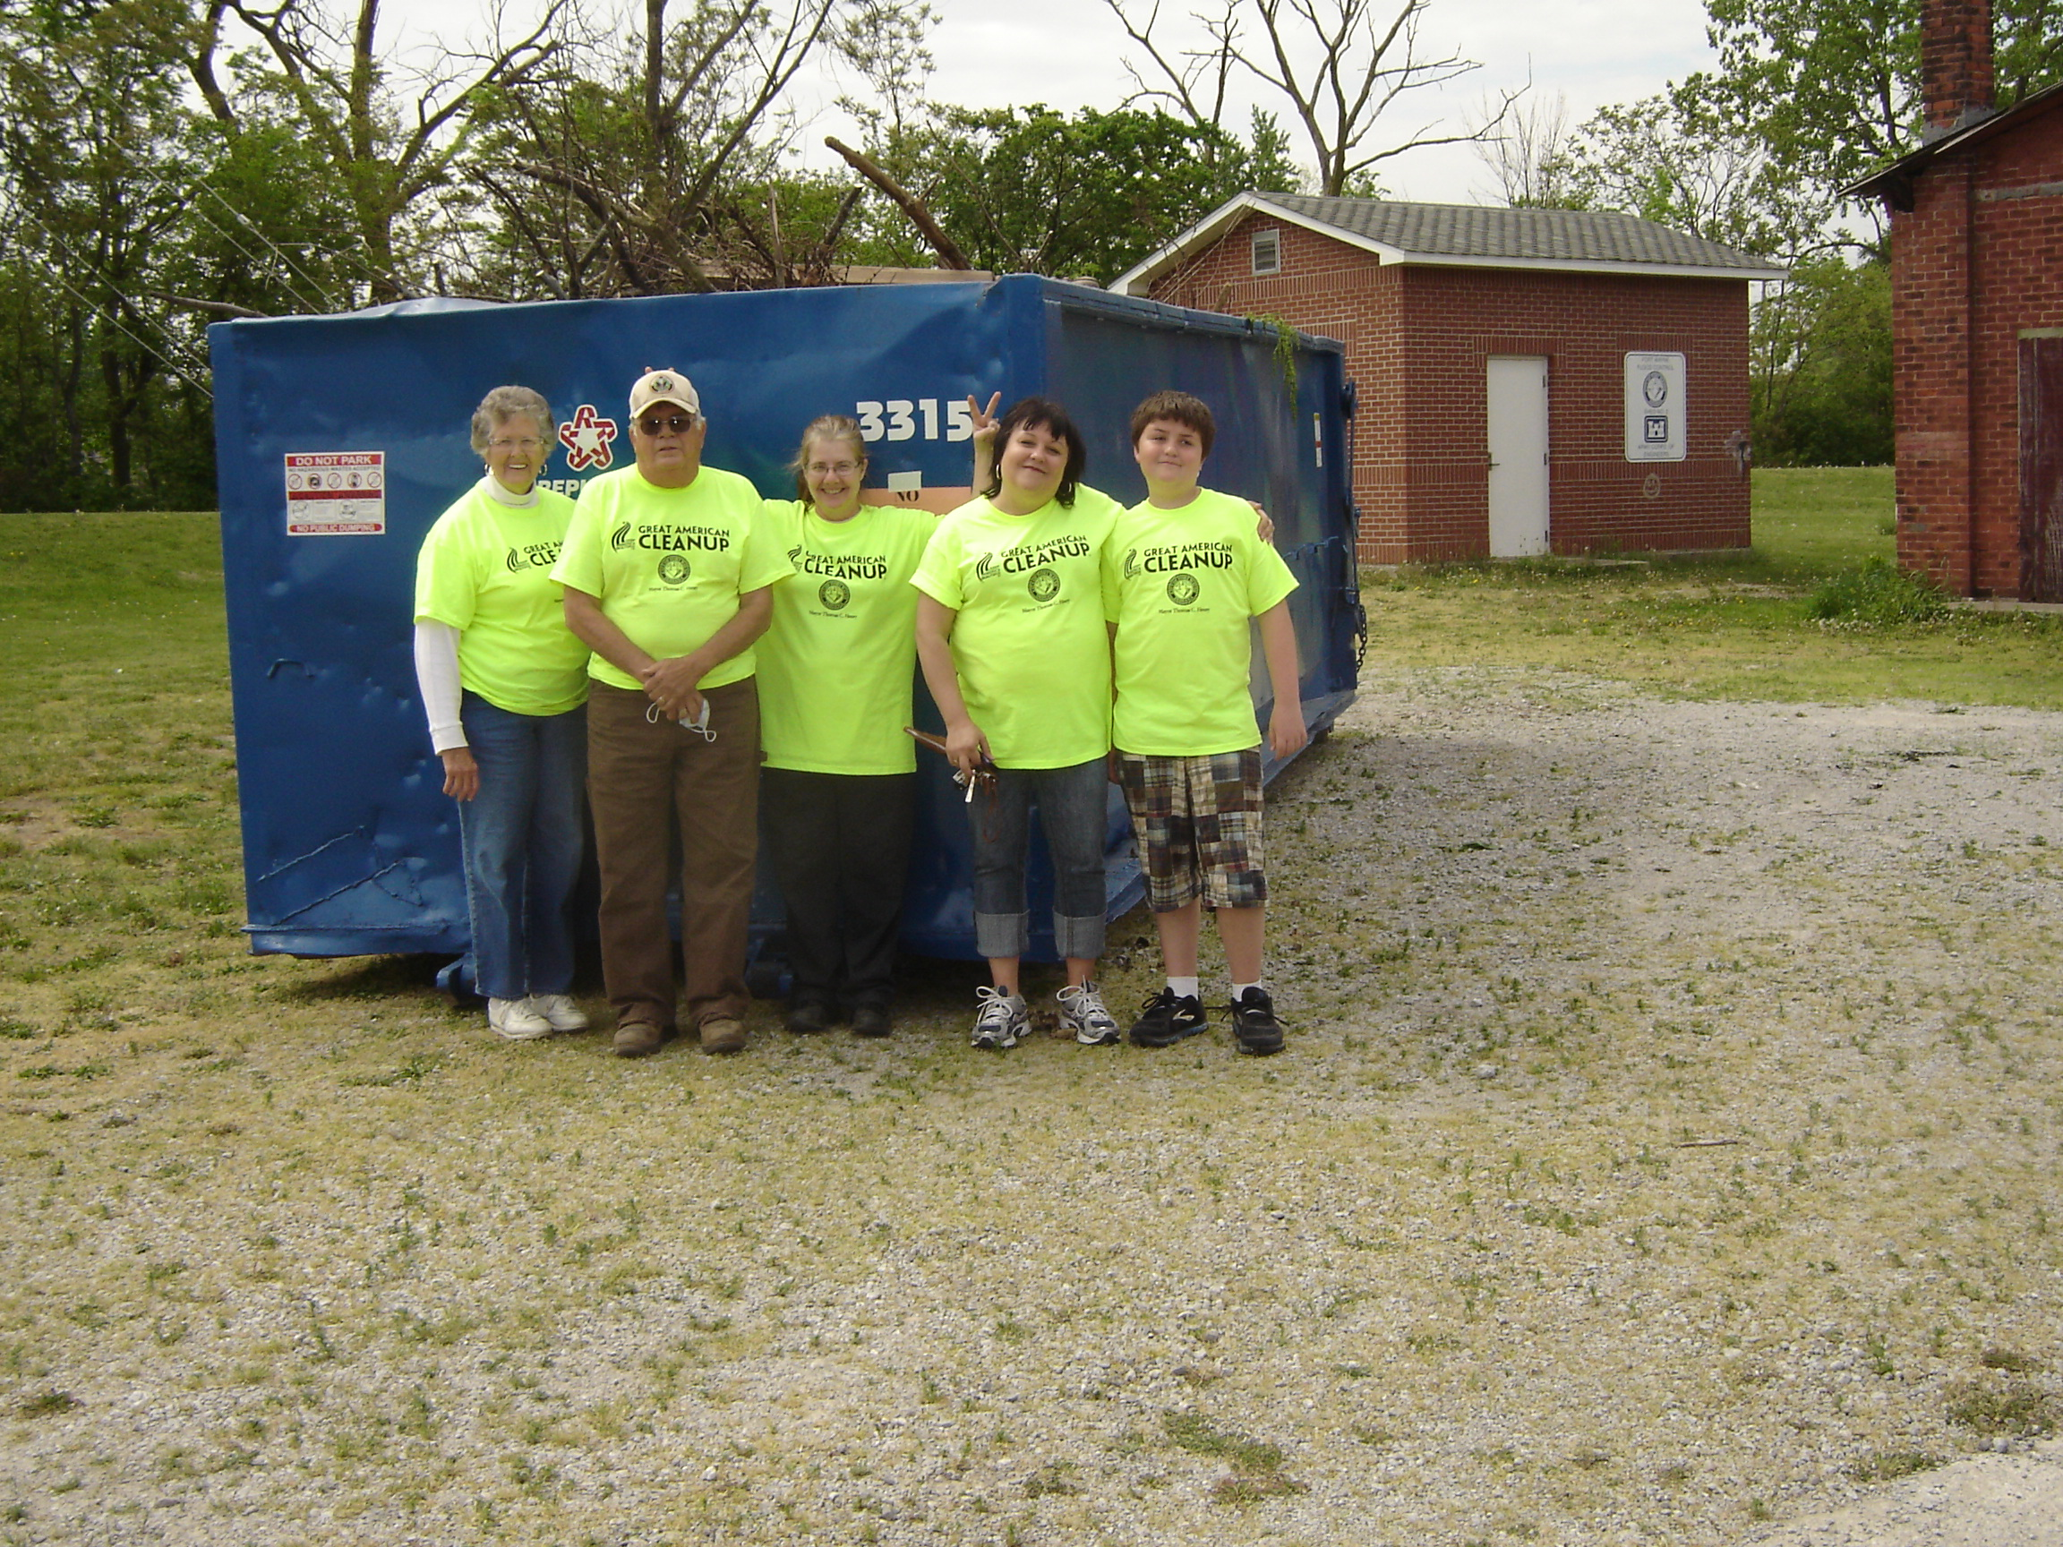
Part of the crew that helped with Bloomingdale Neighborhood Cleanup Day

