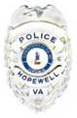
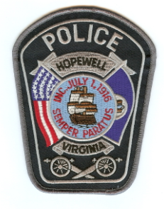
HOPEWELL POLICE DEPARTMENT
300 N. Main Street
Hopewell, VA 23860
John Keohane, Chief of Police
804-541-2282
“10” MOST WANTED
UPDATED JULY 13, 2012

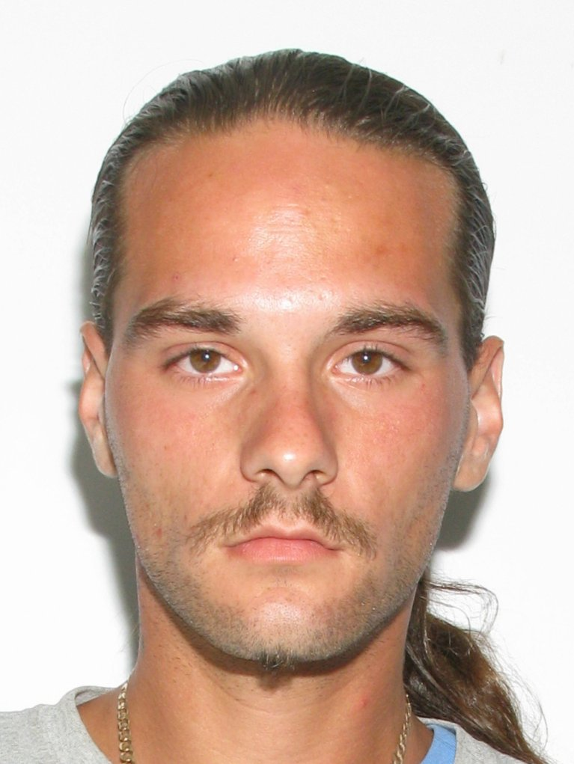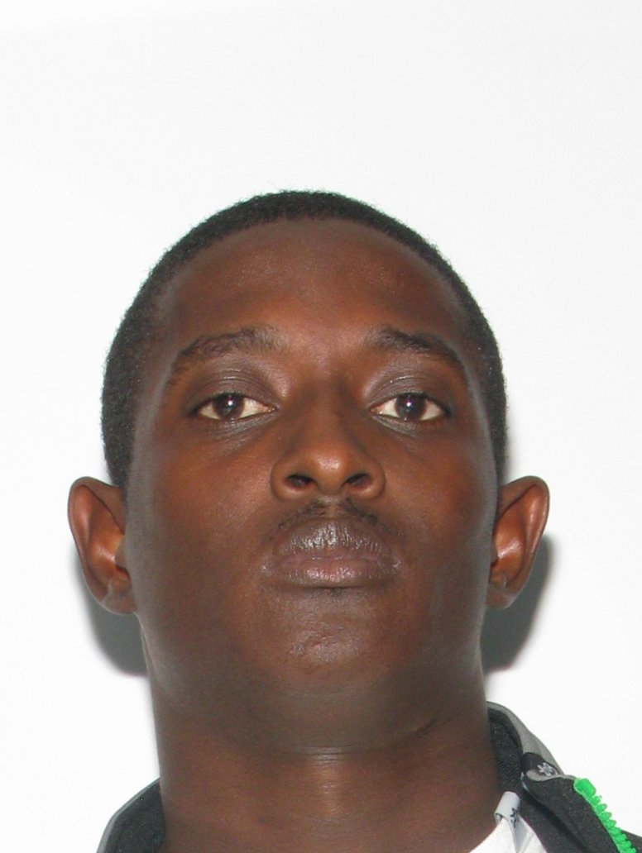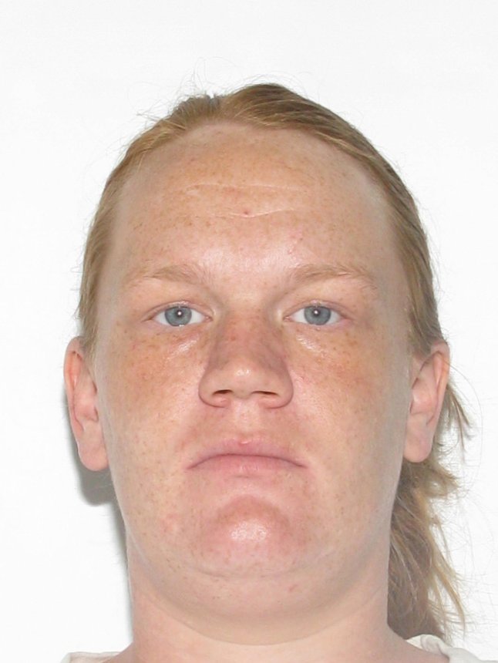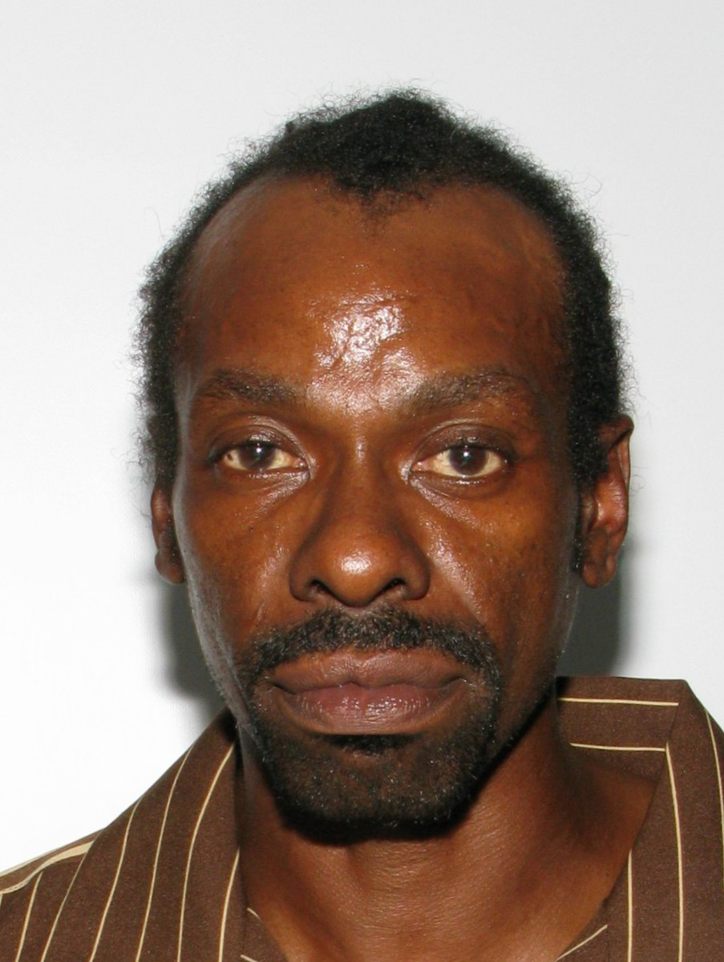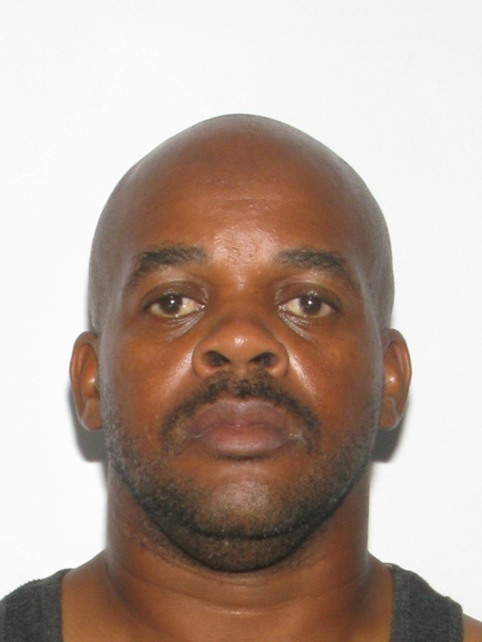
Robert BELCHER Demond CRAWLEY Catherine LIPFORD Kenneth MOORE Kevin H. MILLER
Assault/ False report Probation Violation Probation Violation Assault Unauthorized Use 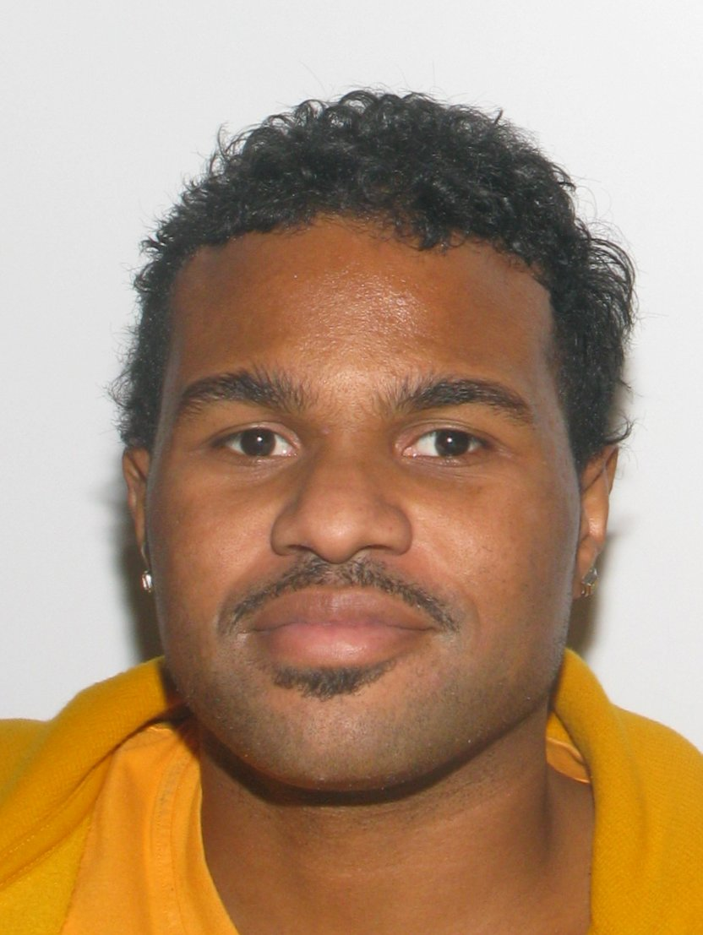 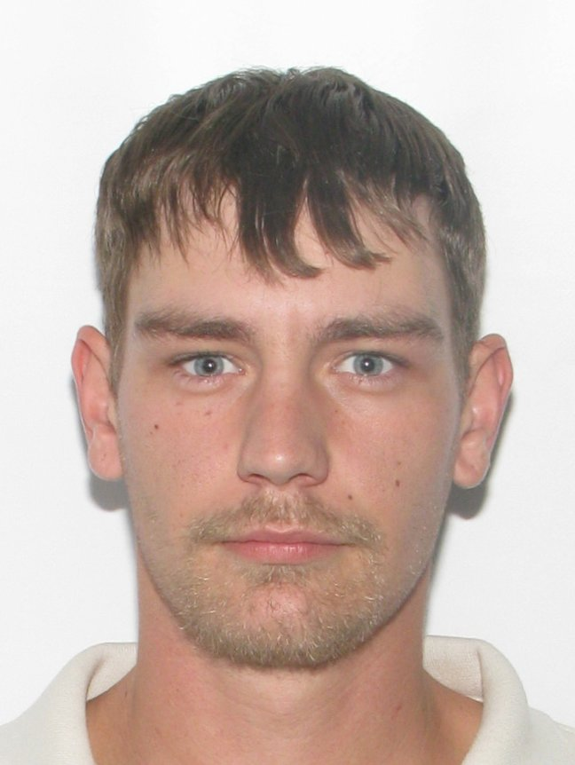 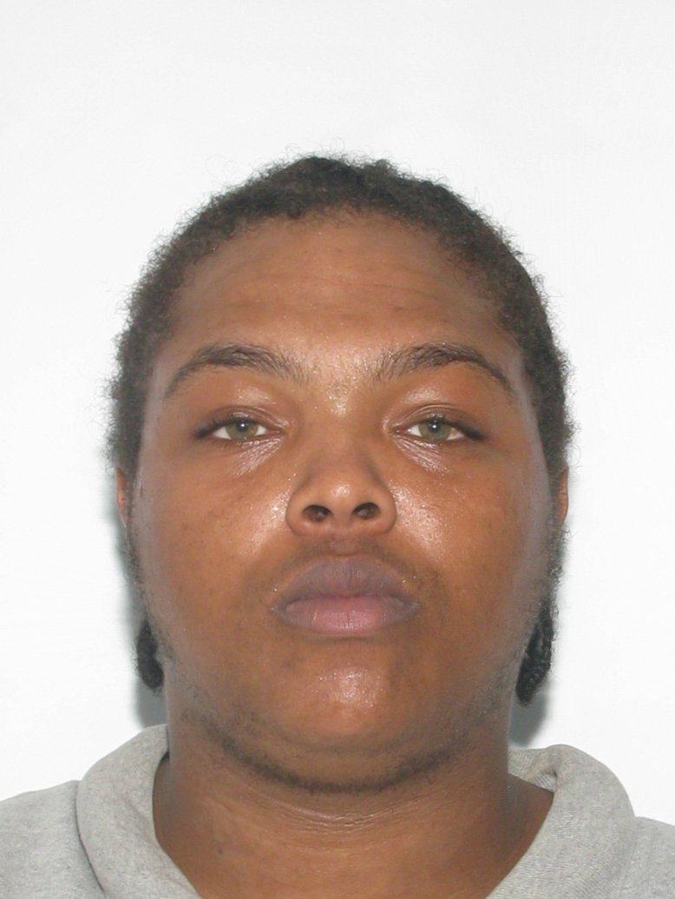 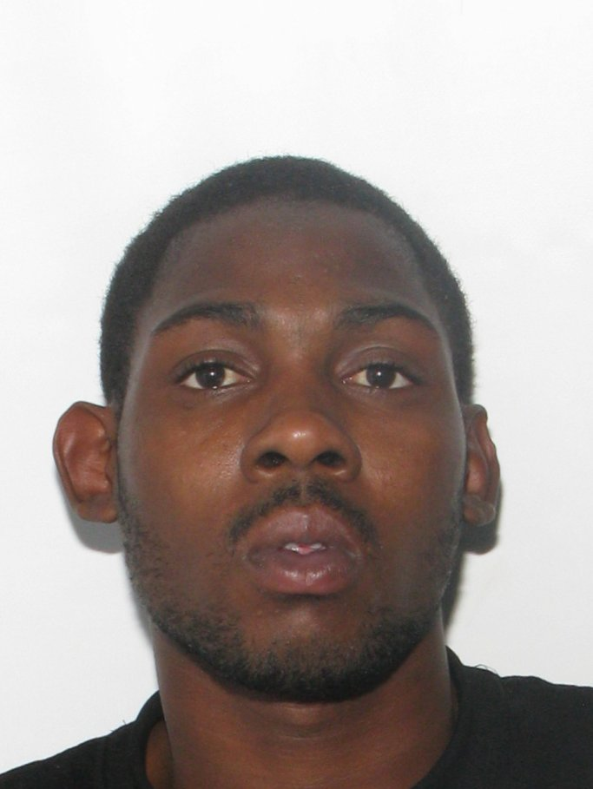 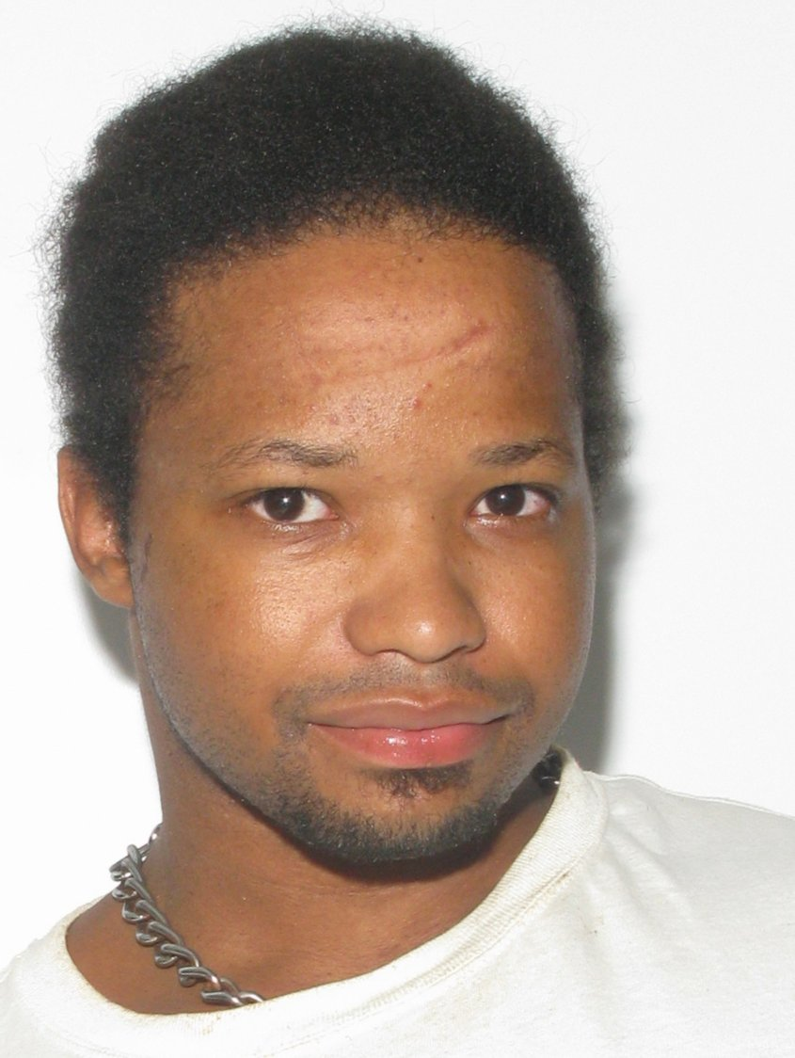 Larry WALLACE Joshua NAVROSKI George A JEFFERSON Jr Ricky STITH Daniel BRADLEY Violation of Court order Felony Assault Grand Larceny Assault Probation Violation

