Discovery/Fairgrounds Sub-Area Plan

December, 2009

Initial Recommendations

Quick Facts

The Discovery/Fairgrounds sub-area is located in a rural area of unincorporated Clark County between Vancouver and Ridgefield. The planning area includes approximately 2,071 acres and extends from NE 164th Street on the south to NE 209th Street in the north. The eastern boundary is NE29th Avenue to NW 11th Avenue.

The area is predominately known for large lot single family residential uses, and undeveloped property, but it is regionally known for the Clark County Fairgrounds and the Clark County Amphitheatre.

Population | 1,562 (2008)
Median household income | $76,452 (2007)
Per capita income | $34,151 (2007)
Percentage of owner-occupied housing | 85%
Gender ratio | 50% Male : 50% Female
Urban Service providers | Clark Public Utilities (water); Clark Regional Wastewater District (sewer); Vancouver School District, Battle Ground School District and Ridgefield School District (schools); Fire District 6 and 11; Greater Clarks Parks District (parks); CTRAN (transit); Washington Department of Transportation; and Clark County
Major taxing districts | Clark County; Vancouver School District; Ridgefield School District; Battle Ground School District; Port of Ridgefield; Fire Districts 6 and 11; and Greater Clarks Parks District.

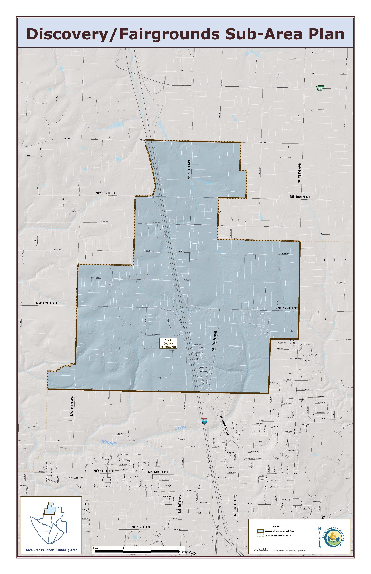
Introduction

In July 2008, the Board of Clark County Commissioners directed staff to advance sub-area planning for the Three Creeks Special Planning Area. The Discovery – Fairgrounds sub-area plan is the second area within the Three Creeks Special Planning Area to be studied. Following the success of the Highway 99 sub-area plan, Discovery/
Fairgrounds area is poised to make an impact on the Three Creeks Special Planning Area.

In September 2009 an advisory group was convened to discuss the sub-area and provide a cohesive direction for the future. The group consisted of Clark County staff, members of the community, representatives from Vancouver, Ridgefield, Battle Ground, WSDOT, development interests, the Amphitheater, and the Fairgrounds.

The Discovery/Fairgrounds sub-area is located in a rural area of unincorporated Clark County between Vancouver and Ridgefield. The planning area includes approximately 2,071 acres and extends from NE 164th Street on the south to NE 209th Street in the north. The eastern boundary is NE 29th Avenue to NW 11th Avenue.

The area is predominately known for large lot single family residential uses, and undeveloped property, but it is regionally known for the Clark County Fairgrounds and the Clark County Amphitheatre.

The population is estimated at approximately 1,560 (2008). Of the 1,560 population base, census information indicates that 4,611 are of working age (20 to 64 years old).

Urban services are provided by: Clark Public Utilities (water); Clark Regional Wastewater District (sewer); Vancouver, Battle Ground and Ridgefield School Districts (schools); Fire Districts 6 and 11; Greater Clarks Parks District (parks); CTRAN (transit); Washington Department of Transportation; and Clark County.

Sub-area Focus

Land Use

The advisory group focused initially on the abundance of residentially zoned land within the sub-area and the idea that the Discovery Corridor should be an economic development engine for Clark County. The sub-areas’ proximity to existing transportation infrastructure including Interstate 5, and its relatively undeveloped acreage makes it an outstanding candidate for economic development planning.

The Clark County Fairgrounds and Amphitheater currently exist and supporting both entertainment venues is a priority for future economic development in the sub-area. Providing the appropriate zoning for needed restaurants in close proximity to these regional facilities would enhance the entertainment experience for visitors.

At the intersection of NE 179th Street, NE 10th Avenue, and Interstate 5 exists substantial vacant acreage zoned for General Commercial uses. It is appropriate to retain that zoning classification in those areas. The General Commercial zone allows for restaurant development and is also the zoning classification most appropriate for a regional retail center. Adjacent to the General Commercial area additional acreage has been proposed for Mixed Use development which adds both a commercial component as well as a residential component to encourage close proximity among working/living/shopping opportunities. Additional commercial zoning designations are believed to be appropriate at NE 10th Avenue and NE 199th Street to encourage local shopping opportunities for residents and employees of future businesses. This intersection is thought to be most appropriate for smaller scale commercial endeavors due to the lack of access directly from Interstate 5.

The northern half of the sub-area is currently dominated by light industrial zoning classifications. While these are potential jobs producing lands, the Advisory Group believes that due to existing environmental constraints, especially along NE 10th Avenue, would preclude many types of industrial development from taking place there. Whipple Creek and its associated buffer would better support Office Campus and/or Business Park type development while retaining land use classifications that support and encourage the development of family wage jobs. An analysis of the VBLM with current land use designations compared to proposed designations shows an increase of the job creation potential from 622 to 2,285 for industrial/business park. Commercial job creation would be reduced significantly under this proposal from 6,849 to 3,626 although much of the decrease is the result of removing the Fairgrounds and Amphitheater from the proposed analysis.

Opportunities for single family residential living have been retained or provided in the sub-area as well. There is a substantial amount of acreage available for this type of development toward the eastern and western boundaries of the Discovery/Fairgrounds sub-area.

Transportation

As a largely rural area prior to the adoption of the 2007 update to the Comprehensive Growth Management Plan Discovery/Fairgrounds has a rural road network. Plans exist to upgrade capacity on NE 179th Street from NE Delfel Road to NE 15th Avenue within the next 10 years. Eventually the upgrade will continue to NE 50th Avenue, but the timeline for that segment of the project is not firm.

The advisory group advocates, in the strongest possible terms, the inclusion of a bridge within the Transportation Capital Facilities Plan to connect NE 10th Avenue across Whipple Creek. A bridge in this location will promote economic development within the Discovery/Fairgrounds sub-area as well as those parcels to the south. A bridge at the location will improve traffic flow to and from the Fairgrounds and Amphitheatre making both venues more visitor friendly. Additionally, a north/south corridor adjacent to Interstate 5 would provide some relief for the intersection of NE 179th Street/NE 10th Avenue/Interstate-5.

Environmental

A large portion of the Discovery/Fairgrounds sub-area is wet and Whipple Creek plays a significant part in the land use patterns that have emerged from the Advisory Group. The parcels along NE 10th Avenue north of NE 179th Street are designated for Light Industrial uses, however due to Whipple Creek and its associated buffer the parcels would likely not be viewed favorably by development interests. Therefore the advisory group has recommended Office Campus and Business Park uses which should provide development opportunities that create family wage jobs within Discovery/Fairgrounds.

