Perkerson Civic Association/Drainage Issues
This analysis is prepared with reference to flood plain maps, aerial photos, and elevation maps. No on-the-ground surveys were made.
I have been asked to evaluate the drainage in the Perkerson area. This area located in the City of Atlanta and the drainage issue of interest is, for our purposes, bounded on the:
north by Langford Parkway,
east by Metropolitan Parkway,
south by a branch of South River
west by City of East Point

In this area, the drainage used to flow generally eastward into tributaries of South River. With construction of I-75, I-85, and Langford Parkway, those older and simpler drainage ways have lengthened and have become more convoluted. The area south of Langford Parkway between Banks Street and Langston Street are drained by an un-named conveyance that proceeds southeasterly through the area crossing Langston Street, presumably through culverts under Langston Street.

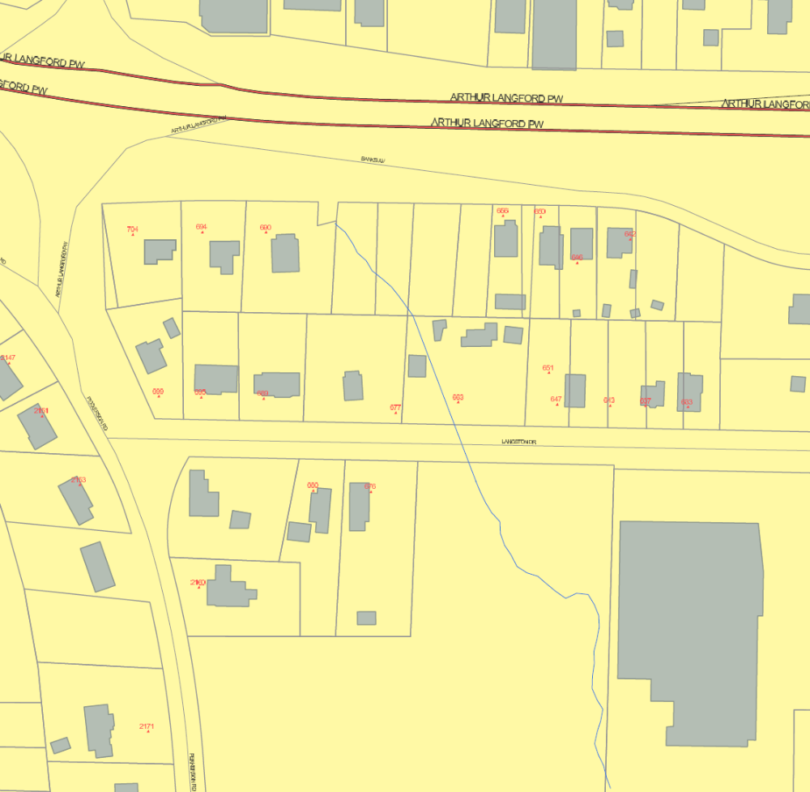
Beginning of Drain for Affected Area.
Drainage Area of Interest

South of Langston street the drain continues between, and along rear lot lines of those parcels fronting on Perkerson Road and Metropolitan Parkway into a wooded area. There is no drainage easement or public access to this area.
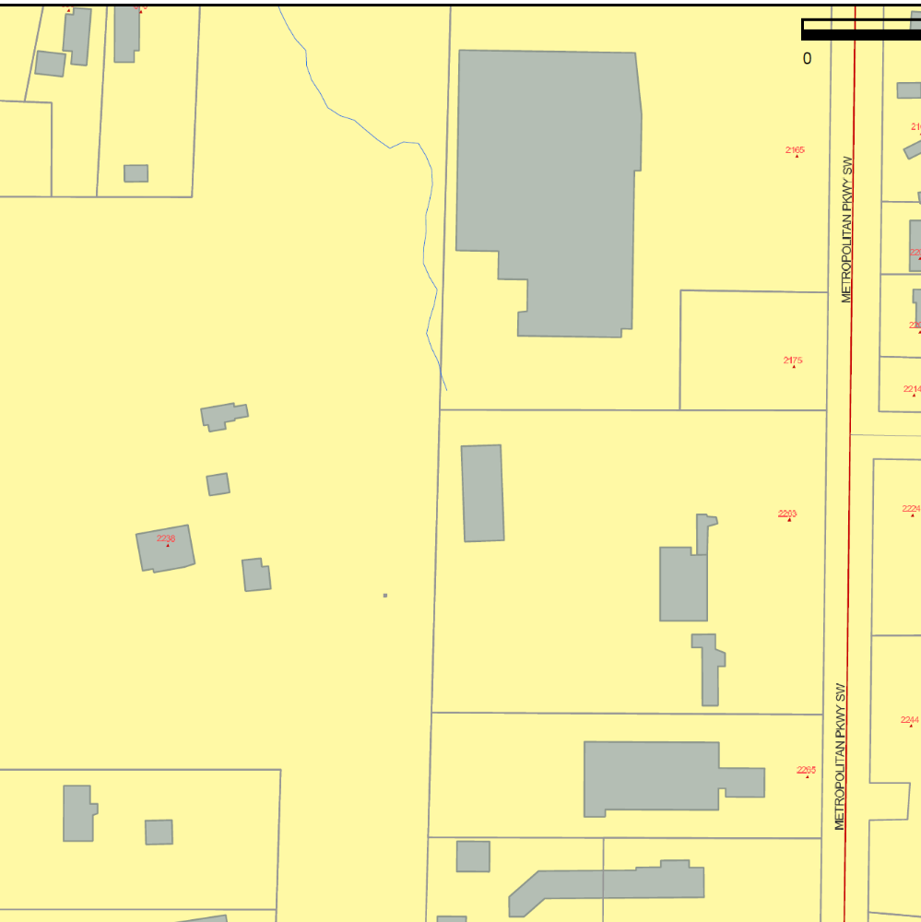
From here, the path of flow is undetermined, but must be to the south or west along non-public waterways.
End of Defined Stream

Please note that the flood affected area is quite far from any designated 100-year floodplain.

Flood Affected Area

Drainage Area of Interest
Regional View - 100-year Floodplain

