2010 Perkerson Media Help

Photo Gallery of Properties
Located at 2500, 2507 & 2512 Perkerson Road
Atlanta, Georgia 30315

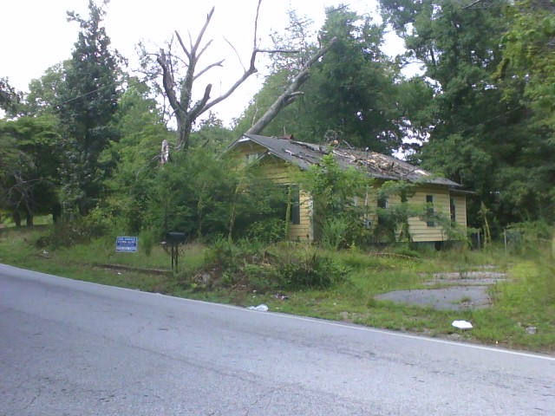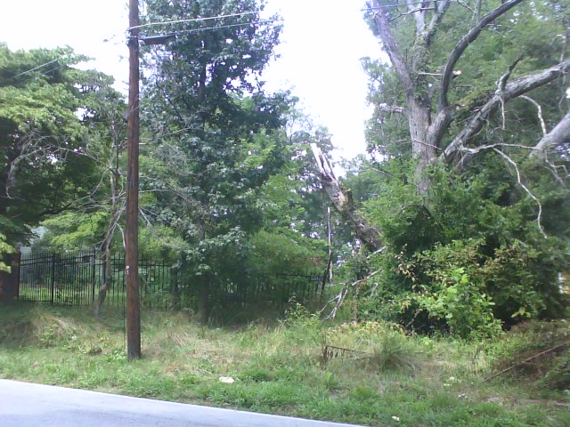

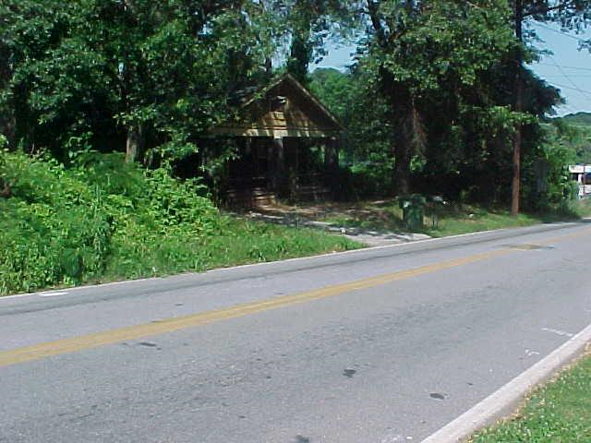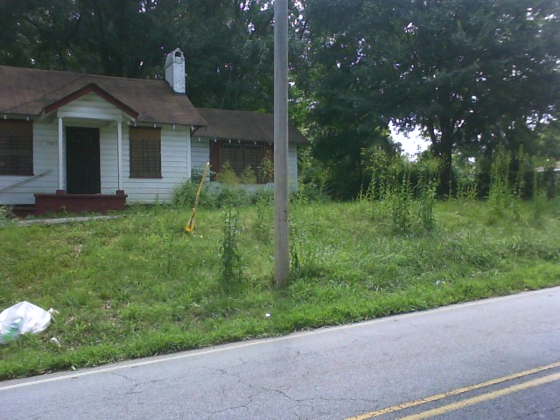

Abandoned Homes

Attract Crime To Perkerson Road

Residents Living On Perkerson Road Catch Criminals Stealing From Abandon Homes
By Adam Murphy, CBS Atlanta Consumer Investigator
POSTED: 5:14 pm EDT July 29, 2010
UPDATED: 8:15 am EDT July 30, 2010

ATLANTA -- Several Atlanta residents complained to CBS Atlanta News on Thursday about some abandoned homes in their neighborhood that have become a magnet for crime. The rundown homes are on Perkerson Road, and for years Leroy Solomon has had to live next to the eyesores.

"We want to see this area cleaned up," said Solomon.

Solomon said he's complained to code compliance and even his council member, but no one has responded.

"We have to come out and look at this everyday and if I let me property look like this they would come and throw a code on me," said Solomon.

The unsightliness is only half the problem for residents like Solomon. He took photographs of a man stealing items from the home at 2500 Perkerson Road a few months ago and last week police arrested a man for stealing copper at 2512 Perkerson Road. So CBS Atlanta News asked Atlanta City Council member Joyce Sheperd about the properties.

"Are you addressing the crime in this community?" asked CBS Atlanta reporter Adam Murphy.

"Absolutely. As a matter of fact, I've just called Major Mitchell to ask him about 2512. You said there were some things going on there last week. I'm waiting on them to call me back to let me know specifically what happened at 2512," said Sheperd.

Meanwhile, residents want city leaders to track down those responsible for the cleanup.

"It seems like everybody that comes to you gets action and you get the job done and that's what we're trying to do is get some action done," said Solomon.

Put the following links in your browser’s address:
http://www.cbsatlanta.com/news/24442636/detail.html
http://www.cbsatlanta.com/slideshow/news/24322949/detail.html

Thank You CBS Atlanta & Reporter Adam Murphy!!!

